CPRE 488
MP-4
UAV Control
Document Version 1.1

Table of Contents
Introduction
Basic Crazyflie operation
Crazyflie LED Codes
Crazyflie System Overview
Virtual Machine Details
Importing the Virtual Machine Instance
Folder Sharing with the Virtual Machine
Exporting Code From the Virtual Machine
Importing Work Into the Virtual Machine
Final export from the virtual machine
Test Stand Details
Test Stand Components
Basic Setup
Using the Test Stand
Ground Station, Graphical User Interface (GUI)
Connect to the backend
Get/Set Parameters
Sending setpoints
Graphing Log Variables
Adding New Logging Variables
Gamepad Control
Command Line Interface (CLI)
Part 1: PID Tuning
Getting Set Up for Part 1
Basic Setup
Flashing the Crazyflie
Attitude Rate Control
1.1 Yaw Rate
1.2 Pitch Rate
1.3 Roll Rate
Attitude Position Control
1.4 Yaw
1.5 Pitch
1.6 Roll
1.7 The Maiden Voyage
Part 2: Writing the Control Algorithm
Control Layout
Understanding the Code
Logging Instructions
Data Structures
Compiling The Crazyflie Firmware
Writing the Code
2.1 General PID
2.2 Attitude Rate Controller
2.3 Attitude Controller
2.4 Student Controller, Bringing it all together
Final Check
What to submit
Extra Credit
Document Version Changelog

Introduction
A MAN HAS FALLEN INTO THE RIVER IN LEGO CITY!
Start the new rescue quadcopter!
HEY!
Program and tune the quadcopter, and off to the rescue!
Prepare the lifeline, lower the stretcher, and make the rescue!
The Crazyflie collection from MicroCART!

Say hello to your Crazyflie drone! The goal at the end of this lab is to be able to smoothly control the Crazyflie with the algorithms that you will write and test. First, we will give you a brief overview of the Crazyflie system, as well as how to get set up with development for this lab.

Basic Crazyflie operation

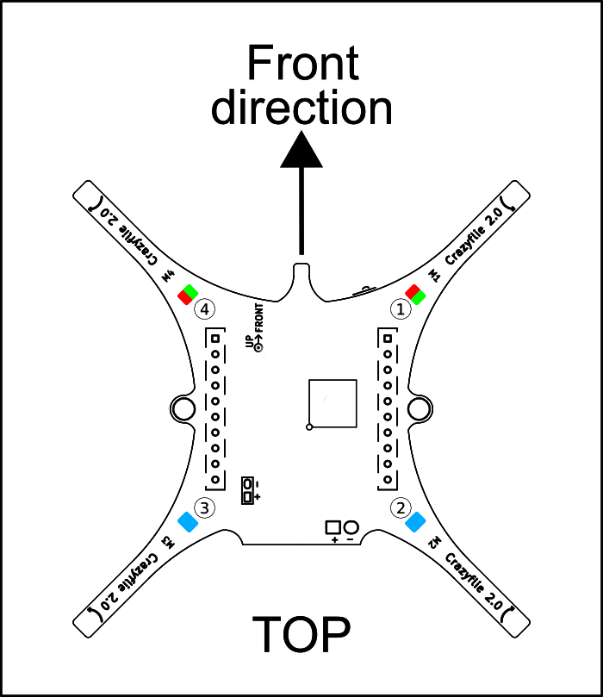
Right
Left
Power
Button
Figure 1. Crazyflie top down diagram
There is only one physical button on the Crazyflie, the power button. To start the Crazyflie:
- Plug in a charged battery
- Press the power button located near the front right arm of the drone
- Wait for all four props to do a short spin and the startup tone to play.
- Place the Crazyflie on a flat surface to allow its sensors to calibrate. This is indicated by the flashing red LED. If it flashes quickly, then the sensors have been calibrated properly and the drone is ready to fly. If the LED flashes slowly, then the sensors have not been calibrated yet. If some hardware is damaged on the Crazyflie it may fail to pass its self check on startup. This is indicated by the red led flashing quickly 5 times. In this case the hardware may be inoperable. If this is the case, notify a TA or the instructor.

Crazyflie LED Codes
One of the main ways the Crazyflie communicates its status is with the four LEDs mounted to the surface.

LED code | Meaning
2 solid BLUE | All normal, indicates the back of the Crazyflie
2 Slow flashing BLUE (1 hz) | Crazyflie is in bootloader mode and is ready to be flashed by radio
1 Fast flashing BLUE (2 hz) | Crazyflie is in DFU mode and is ready to be flashed by USB
Back left BLUE flashing | Charging while plugged into USB. Percentage of time LED is on indicates battery level.
1 slow flashing RED (0.5 hz) | Crazyflie is on but sensors are not calibrated. Place on a flat surface and keep still to calibrate
1 fast flashing RED (2 hz) | Sensors are calibrated and ready to fly
5 short RED pulses followed by a gap | Self test failed, hardware may be damaged, notify a TA or the instructor
1 solid RED | Low battery
5 short GREEN pulses | Self test passed, all normal

Crazyflie System Overview
This is the complete Crazyflie control system. You will only be modifying a small portion of it, but it will be helpful to understand the full scope of the system you are interfacing with.

The control process starts with the state estimator module receiving sensor data and using it to calculate the drone's current attitude (its rotation, i.e. roll, pitch, and yaw). The state estimator then sends the calculated attitude to the state controller module, which also receives a setpoint from the commander module (in our case, this is user input specifying the desired attitude or attitude rate and thrust). The state controller module contains a cascading PID controller that uses the inputs from the state estimator to calculate the actuation force needed. That is then sent to the power distribution module where the actuation force is converted to motor power then the loop starts over again.

You will be implementing the State Controller’s cascading PID in part 2 of this lab.
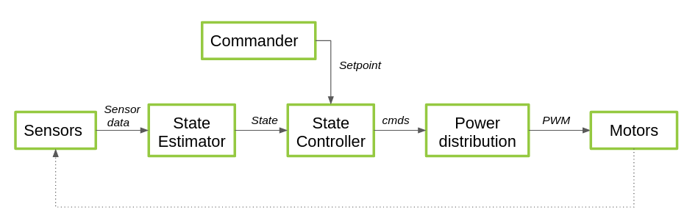Figure 2. Crazyflie control diagram

The Crazyflie runs off of a cascaded PID system where the output of the first PID controller is then used as an input for a second PID controller. This layout can be seen in figure 3, the output from the attitude PID controller, the desired attitude rate, becomes the input of the attitude rate PID controller. In part 2, you will be implementing the attitude and attitude rate PID controllers for roll, pitch, and yaw.
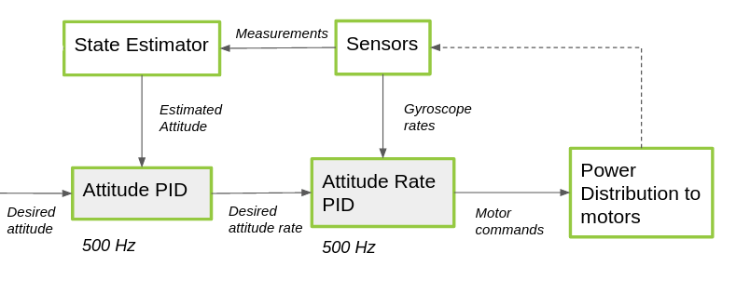
Figure 3. Cascading PID diagram

Virtual Machine Details
The virtual machine has been configured to have the necessary utilities to develop the Crazyflie firmware. Below are detailed instructions for completing different tasks within the virtual machine. Login username is bitcraze and password is crazyflie

Importing the Virtual Machine Instance
New users will not be able to see the VM instance until it is imported.
- Open Virtual box application
- Go to machine → add
- Navigate to the VM installation, C:\cpre488\mp-4\
- Open the .vbox file
- The virtual machine should now be available

Folder Sharing with the Virtual Machine
- Go to VM settings, machine → settings then shared folders
- On the far right click the blue folder with a green cross to add a new shared folder
- Set the folder path to a folder on the windows system to share with the VM
- Select Auto-mount
- For the mount point enter ‘/home/bitcraze/shared-folder’ or some other specified mount point
- Select make permanent
  - This option is only available while the vm is running
- Select ok on both dialog boxes to complete the shared folder setup
- You should now be able to navigate to /home/bitcraze/shared-folder in the VM and see the files in your shared folder

Exporting Code From the Virtual Machine
Due to the read only VM image, you must export your work from the VM before shutting down. The VM will be reset on reboot and all changes will be reverted.

There are two options to maintain and export your changes from the virtual machine. The first is to use a local git repository stored on your x drive or a usb flash drive. This minimizes network usage. The second option is to use a standard GitHub or GitLab repository. This option is best for working with other people in your group at the same time. If you do use the second option we ask you make your repo private.
With a bare git repository on the host machine
- Create a bare repository on your x drive or a removable media device
  - ‘git init --bare my_repo_name.git’
  - This will create a folder called my_repo_name.git with no working tree.
- Share this folder with the VM and mount it at ‘/home/bitcraze/transfer-repo.git‘, see details on sharing a folder with the VM
- Once the bare repository is accessible from within the VM, the Microcart repository should already be setup to use ‘/home/bitcraze/transfer-repo.git’ as a remote, check this with ‘git remote -v’
- Commit and push your changes to your shared folder
  - If this fails try setting the remote url again with ‘git remote set-url origin <absolute path to shared folder>’
- Your changes will now be on the bare repo in your shared folder, these changes can now be reapplied later
  - This can be verified by navigating to ‘/home/bitcraze/transfer-repo.git’ and running git log Lab_Part_2
With normal GitHub/GitLab repository
- Note: the first commit may take a while as all the git history must be uploaded
- Create a new private blank repo on github or gitlab, obtain the url or ssh address to the repo
- In the Lab_Part_* folder run ‘git remote set-url origin <address of remote repo>’
  - Note this set-url command must be run each time the VM is rebooted due to the immutable hard drive setup
- Commit and push your changes as normal

Importing Work Into the Virtual Machine
With a bare git repository on the host machine
- Ensure the bare repository is accessible within the VM, see details on sharing a folder with the VM, mount it at ‘/home/bitcraze/transfer-repo.git’
- The Microcart repo should already be setup to use ‘/home/bitcraze/transfer-repo.git’ as a remote
- From within the Lab_Part_* folder run ‘git pull’
With normal GitHub/GitLab repository
- Set the remote repository with ‘git remote set-url origin <address of remote repo>’
- From within the Lab_Part_* folder run ‘git pull’

Final export from the virtual machine
Final export will copy all files that have been modified since the original state of the Microcart repo.
- Ensure folder sharing and your git repository are setup correctly
- Commit all changes within the git repository to be exported
- From the root of the Lab_Part_2 folder, Run ‘cp -pv --parents $(git diff Lab_Part_2_tag --name-only) <DESTINATION-DIRECTORY>’
  - The destination should be a shared folder other than your transfer repo so the files are accessible from the host machine
  - This will copy all modified files since the Lab_Part_2_tag into the destination directory

Test Stand Details

Test Stand Components
The test stand for MP-4 is a bit more complex than the ones used in MP-1, and consists of three major components, plus a couple wires to connect them. The test stand base holds the rotary encoder used to measure position, and can be used in two different configurations depending on the drone orientation needed.

The test stand mount attaches to the encoder shaft, and holds the Crazyflie drone in place through friction. There are two different mounts, which can hold the drone in either a horizontal or vertical position.
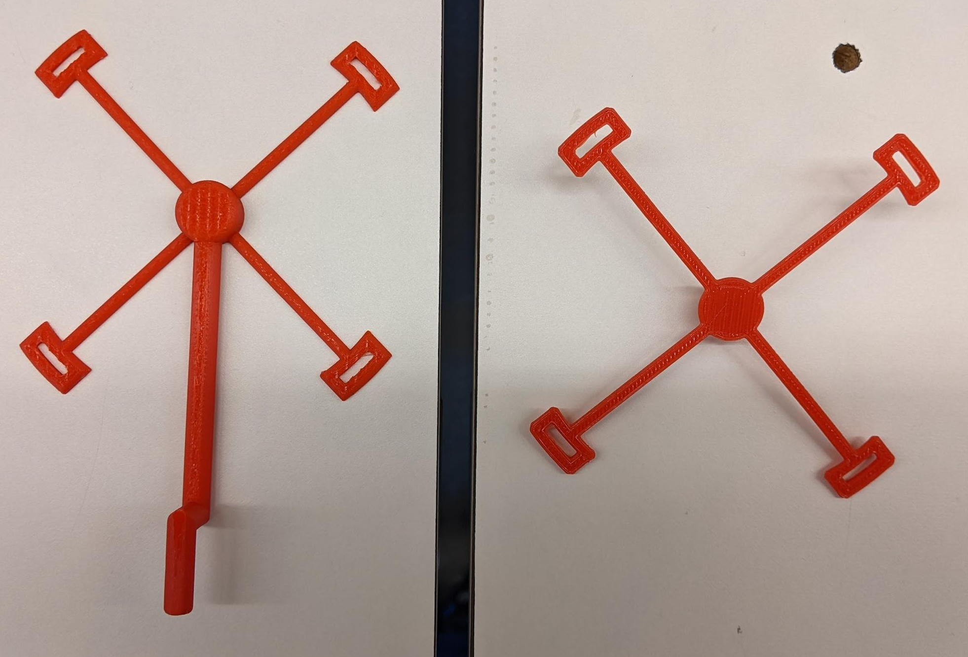
Finally, the test stand control board reads the rotary encoder value, and transmits either positional or rotation rate data to the computer.
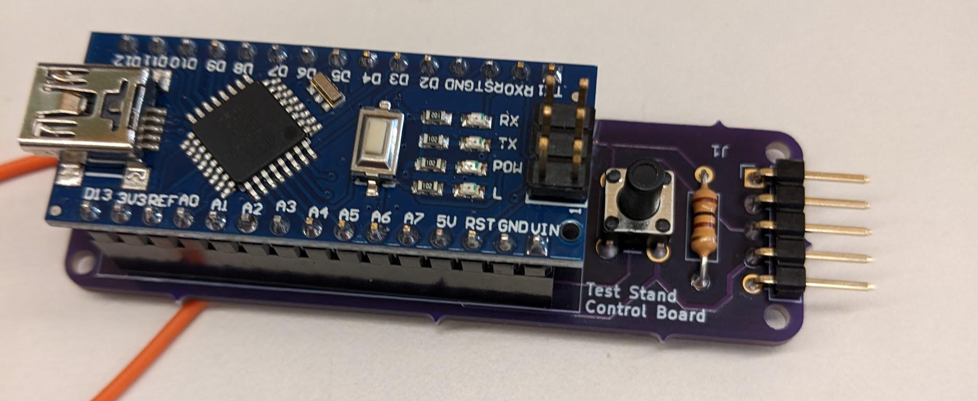

Basic Setup
- Start the Crazyflie drone on a flat surface before you attach it to the desired mount
- Attach the drone to the mount by inserting each pair of clear plastic legs to a corresponding slot in the mount. If you’re using the vertical drone mount, make sure that the drone is mounted appropriately to measure either pitch or roll
- Once the drone is mounted, insert the shaft of the mount into the hole on the top of the test stand base, making sure it fits snugly and doesn’t rub against the sides.
- Plug the small three pin end of the gray cable into the rotary encoder. While you are able to only insert the plug in the correct orientation, please do not force the plug if you are met with resistance. Both the cable and the rotary encoder are fairly expensive, and we only have so many replacements
- Plug the other end of the gray cable into the 5 pin connector on the test stand control board. Make sure to pay attention to the orientation of the connector, since this end of the cable can be plugged in backwards, although doing so shouldn’t harm anything. Make sure that the black wire on the cable connects to the connector pin with the square solder pad.
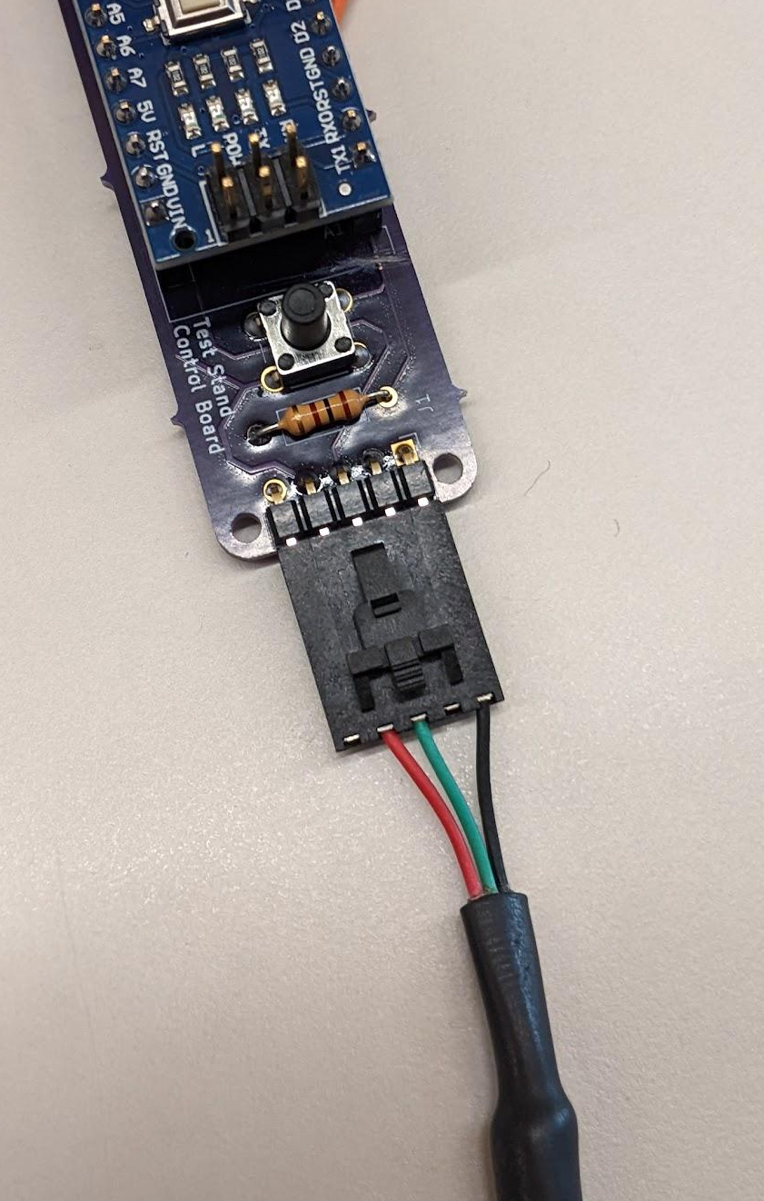

- Finally, connect the Arduino Nano to your PC using a mini USB cable.

Using the Test Stand
The test stand has two modes, where it reports either positional data or the rotation rate (in deg/sec). The LED labeled “L” on the Arduino Nano is used as a mode indicator, and is on when the control board is in position mode, and off when in rate mode. You can switch between modes by pressing and holding the black pushbutton mounted to the control board PCB. Additionally, the black pushbutton is used in positional mode to zero the reported reading (sort of like “tare” on a digital scale). Short pressing the button while in positional mode will reset the reading to treat the drone’s current position as zero. While you will be able to see the reported data in the GUI, you can read the data reported by the controller by connecting to its COM port with PuTTY (or similar) at a baud rate of 9600.

Ground Station, Graphical User Interface (GUI)
The ground station software is what you will mainly be using to communicate with the Crazyflie. It has been pre installed and set up on the virtual machine for this lab.

To connect to a Crazyflie and open the GUI, make sure the Crazyflie is powered on and the crazyradio is available in the vm, then run the command crazycart <radio channel of Crazyflie>. If everything connects successfully, the GUI will open. Below are some details on how to perform tasks in the GUI.

Connect to the backend
Connects the GUI to the backend, you will need to do this every time you start the GUI
- Navigate to the backend tab
- Make sure the text box says ./BackEnd
- Click connect
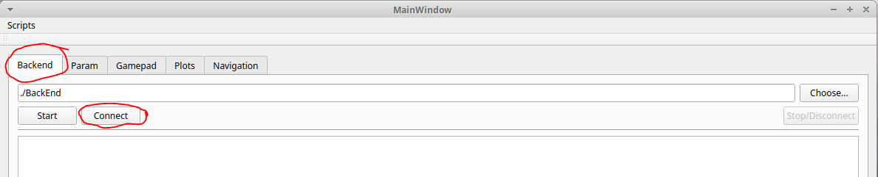

Get/Set Parameters
Lets you view and set parameters of the Crazyflie
- After connecting to the backend, navigate to the param tab
- The top half lets you view the parameter values of the Crazyflie while the bottom half lets you set those same parameters
- You first have to select the group that the parameter is part of then you can select a specific parameter in that group

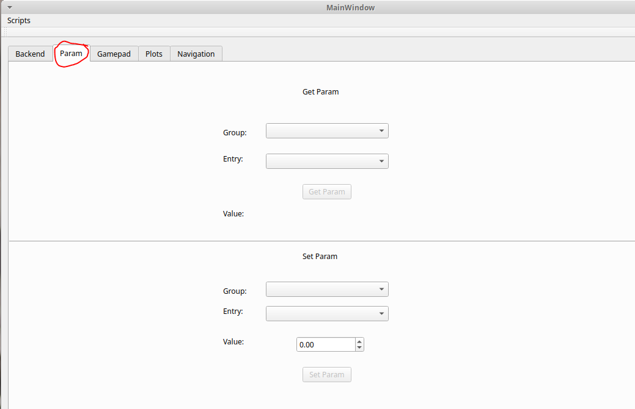

Sending setpoints
Sends setpoints to the drone
- Navigate to the control tab
- Make sure manual setpoint is selected
- You can enter desired pitch/roll/yaw and slide the thrust in the boxes below
- You then chose if you want to send a rate or angle setpoint then click apply to send it
- Clicking stop will send a stop setpoint (all inputs 0) to the drone
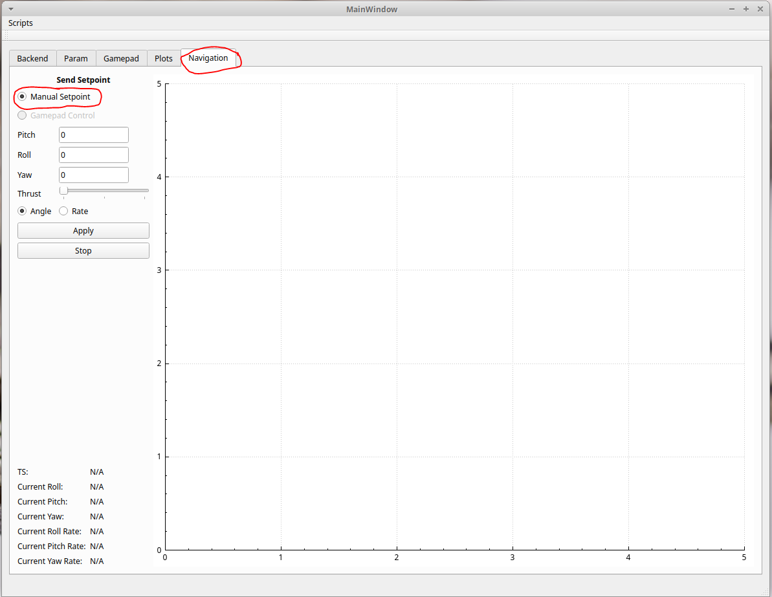

Graphing Log Variables
- See Adding New Logging Variables if needed
- With the crazyflie connected, navigate to the Control tab
- In the side bar you can specify up to 5 variables from active logging blocks to plot on the right
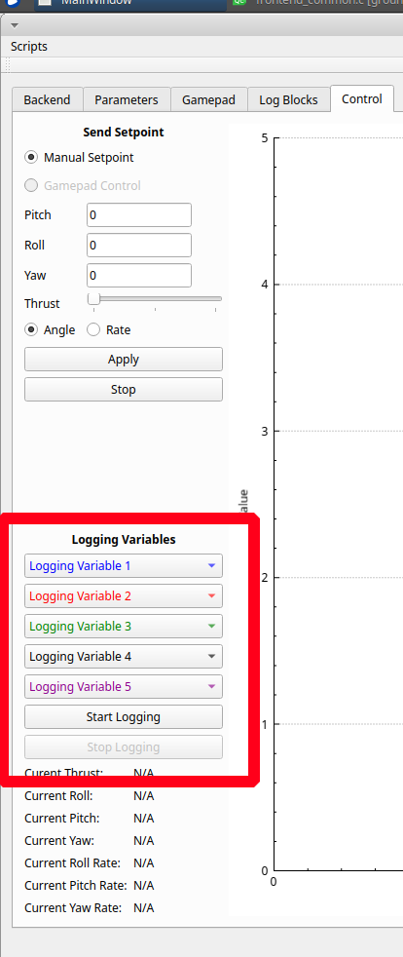
- Once variables are selected click start logging to capturing data
- Press the stop logging button when you are done capturing data.
- The data will be displayed in close to real time. After plotting has stopped you can zoom in and move around the graph.
  - If nothing is plotted after clicking start logging, refreshing the log block can help, see Adding New Logging Variables

Adding New Logging Variables
The crazyflie uses what are called “Log Blocks” to define what variables are logged and sent to the ground station. A log block specifies what values to send and at what rate. Log blocks can be paused and resumed after initial setup. Note the crazyflie communication has a limited bandwidth, only enable around 10 logging variables at a time.
- Navigate to the Log Blocks tab
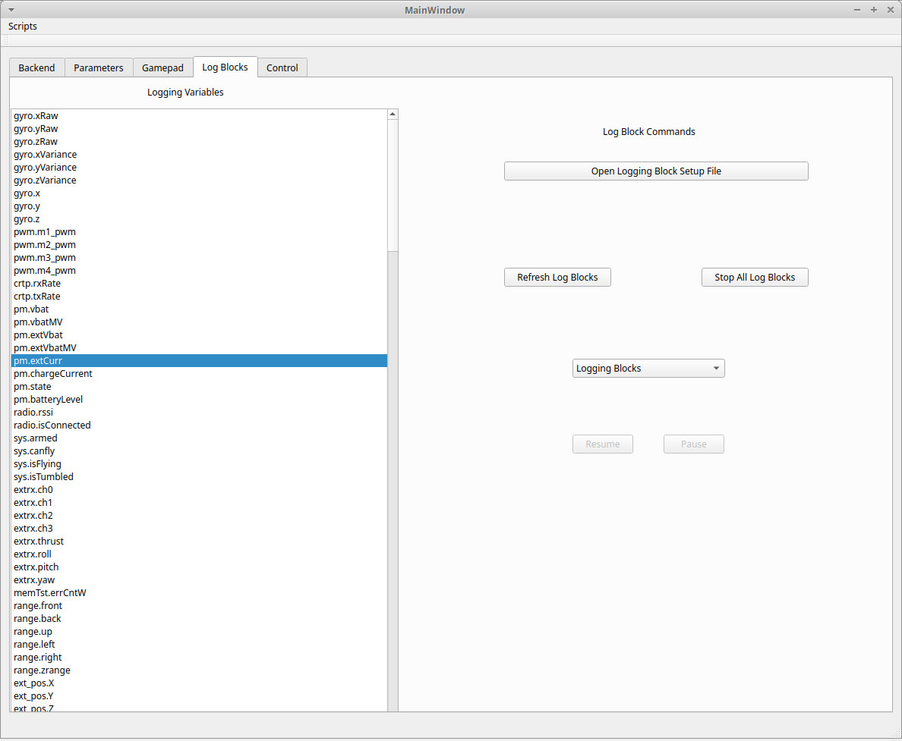
- The list on the left shows all available logging variables from the Crazyflie firmware
- To view and modify what logging variables are sent, click the “Open Logging Block Setup File”
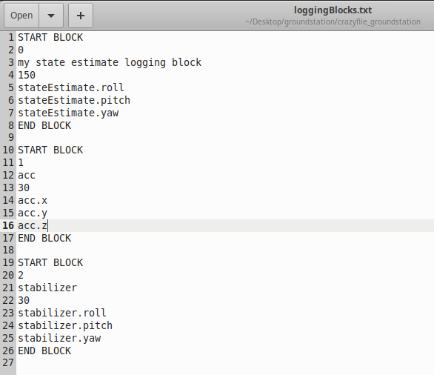
  - The logging blocks have a defined format that must be followed
    - A block definition starts with START BLOCK
    - The next line is the logging block integer id, it must be unique to other logging blocks defined
    - The next line is the name of the logging block, this can be any string you’d like
    - The next line is an integer defining the rate of the logging block, a higher number pushes more data to the ground station. Note, too high of a rate can overload the graphing visualization and cause the GUI to slow down. Safe values are below 100.
    - The following lines define the variables that are in the logging block, these are defined by the firmware and can be viewed in the large list mentioned above. Any number of variables can be in the log block and they do not have to be from the same logging group.
    - A block definition ends with END BLOCK
    - Any lines that are outside of a block definition are ignored
- Save and close the logging block definition file
- Click Refresh Log Blocks to send the new definition file to the crazyflie
- The drop down on the right should now show your new logging block and will be active
  - 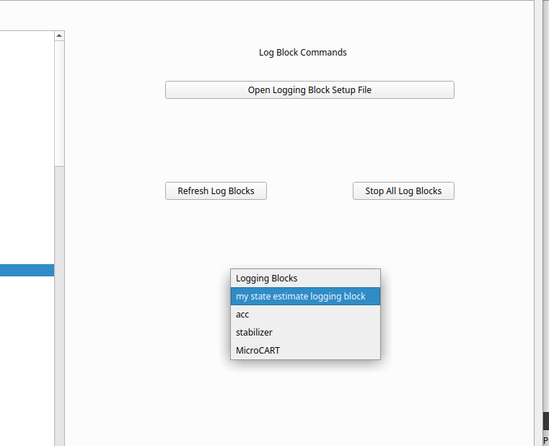
- If needed, you can increase available bandwidth during logging by pausing all other log blocks, selecting your new one from the drop down, and resuming it.
  - The stop all log blocks removes the log blocks from the Crazyflie. You will need to pause each log block one by one

Gamepad Control
Control Crazyflie with gamepad
- Be sure to pass the usb gamepad to the VM by clicking the USB symbol in the bottom right of the window and selecting the gamepad
- Navigate to the Gamepad tab
- The provided gamepad should be configured already, if not you can click the configure tab then move the joystick to the max and min value to calibrate it

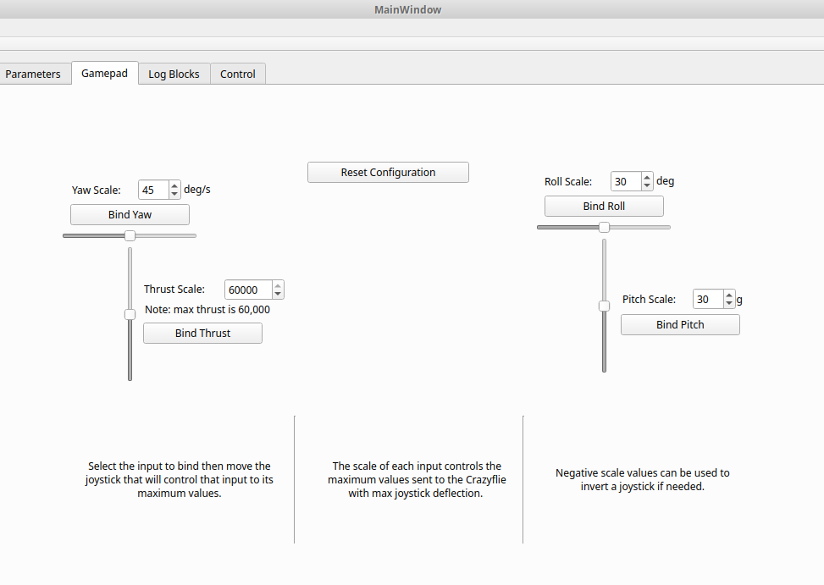
- Navigate to the control tab and select the gamepad control button after you have plugged in your controller. The ground station will immediately start sending setpoints to the crazyflie.

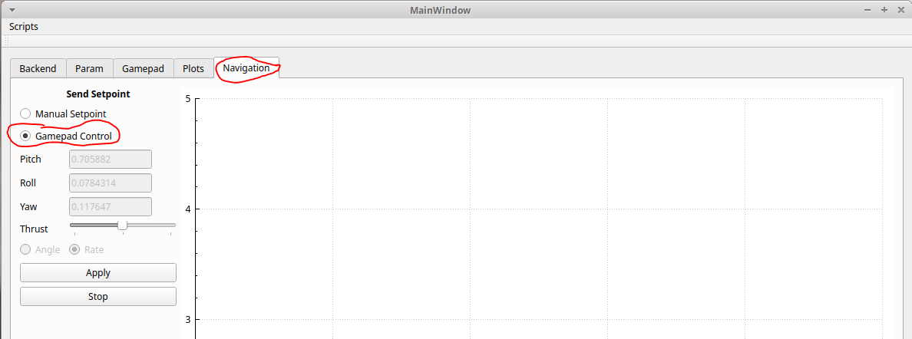

Command Line Interface (CLI)
The CLI is the base of the communication with the Crazyflie drone. It can optionally be used for basic tasks. You shouldn’t need to interact with the CLI during the course of the lab, but it can be useful for debugging if something goes wrong. It can be opened by adding a “nogui” flag to the end of the crazyCART script. crazycart <radio channel> nogui

Run commands with ./Cli <command> <parameters>...

Further usage details can be found by appending --help to the end of a command. The following commands are currently implemented.

Command | Description
./Cli outputoverride <enable> <Time> <Throttle> <Pitch> <Roll> <Yaw> | output override will send a setpoint that lasts a set amount of time with the specified throttle, roll pitch and yaw. With enable set to 1 it will send the setpoint as a rate and 2 will send the setpoint as an angle
./Cli getparam <block_id|'block_name'> <param_id|'param_name'> | Get param will get the value of specified param.  Note only the param id is used for this command. The param id is found in the logging TOC, use getlogfile 1 command to find this file
./Cli setparam <block_id|'block_name'> <param_id|'param_name'> <value> | Set param will set the value of the specified param
./Cli getlogfile <id> | Get log file will get a certain log specified by the id of  0: data log  1: param id  2: logging toc
./Cli logblockcommand <id> | The log block command performs specific tasks on log files for the specified id of  0: delete all log blocks  1: refresh all log blocks  2: load log blocks  3: delete log block  4: resumelog block  5: pause log block

Part 1: PID Tuning
In the first part of this lab you will be tuning PID values of the default controller through experimentation. This will be done through the ground station GUI which will display information from the test stand.

You will be provided a semi-working controller that you will need to flash onto the Crazyflie. This file can be found in the Lab_Part_1 folder on the desktop. From there follow the directions in the Flashing Crazyflie section. This controller works except that all PID constants have been set to 0, you will view and set these constants from the ground station GUI. Important note: The PID constants will be reset to 0 when the Crazyflie reboots! Be sure to copy down your current values as you work to avoid data loss.

A note when tuning the roll and pitch axes, be sure to set the e_stop parameter under the sys group to 0 during testing. By default the Crazyflie will kill motor power if it detects it is tumbling (these tests trigger a false positive). The Crazyflie must be rebooted if this happens.

Getting Set Up for Part 1

Basic Setup
- Setup the virtual machine environment
  - Import virtual machine
- Open virtual box VM
  - Login username is bitcraze and password is crazyflie
- Plug in the Crazyradio into the usb port
- In the bottom right corner of the VM there is a USB icon, make sure the Bitcraze Crazyradio is selected under this menu
  - This can be finicky, may have to physically reconnect the radio a couple of times for it to connect successfully to the VM
- Turn on drone by pressing the button located on the front of the drone
- Get the radio channel for your drone from the provided spreadsheet
  - Crazyflie Status Sheet
- Flash the drone with the pre-compiled firmware that has the no PID values set from the Lab_Part_1 folder. See the Flashing the Crazyflie section for details
- Place the drone on a level surface (not the test stand) and allow it to calibrate
  - See LED codes for more details
- Connect to the crazyflie by running crazycart <radio channel>
- Connect the GUI to the drone via the backend tab
- To make sure you are connected to the drone send a low thrust setpoint with no roll, pitch, or yaw setpoint, the motors should spin up
- Once ready proceed to Part 1: PID Tuning

Flashing the Crazyflie
- Navigate to the Crazyflie firmware folder, ex: ‘~/Desktop/Lab_Part_1/crazyflie_software/crazyflie-firmware-2021.06/’
- Plug in the Crazyradio into the usb port
- In the bottom right corner of the VM there is a USB icon, make sure the Bitcraze Crazyradio is selected under this menu
  - This can be finicky, may have to physically reconnect the radio a couple of times for it to connect successfully to the VM
- Create the file ‘crazyflie_software/crazyflie-firmware-2021.06/tools/make/config.mk’ if it doesn’t already exist and open with VS code
- Add CLOAD_CMDS = -w radio://0/<radio_channel>/2M to the file and replace <radio_channel> with your Crazyflie’s radio channel
  - Your radio channel can be found in this spreadsheet Crazyflie Status Sheet
  - This is a one time process and should not have to be done for any subsequent flashes unless you change which drone you are using or what folder you are flashing from
- Make sure the Crazyflie is powered on and running
- For Part 2 of the lab, compile the Crazyflie firmware with make CONTROLLER="Student" from the root of the Crazyflie firmware
- Then run make cload to begin flashing the compiled firmware to the Crazyflie specified earlier.

Attitude Rate Control
We will begin by tuning the attitude rate controller. This controls the rate of rotation of the yaw pitch and roll.
Tip: When tuning your rate controller, allow for a “looser” control. IE the percent overshoot and settling time can be a bit larger than typically desired. This allows us to tune the attitude controller “tighter” later. It is very difficult to get both controllers tight and is not recommended.

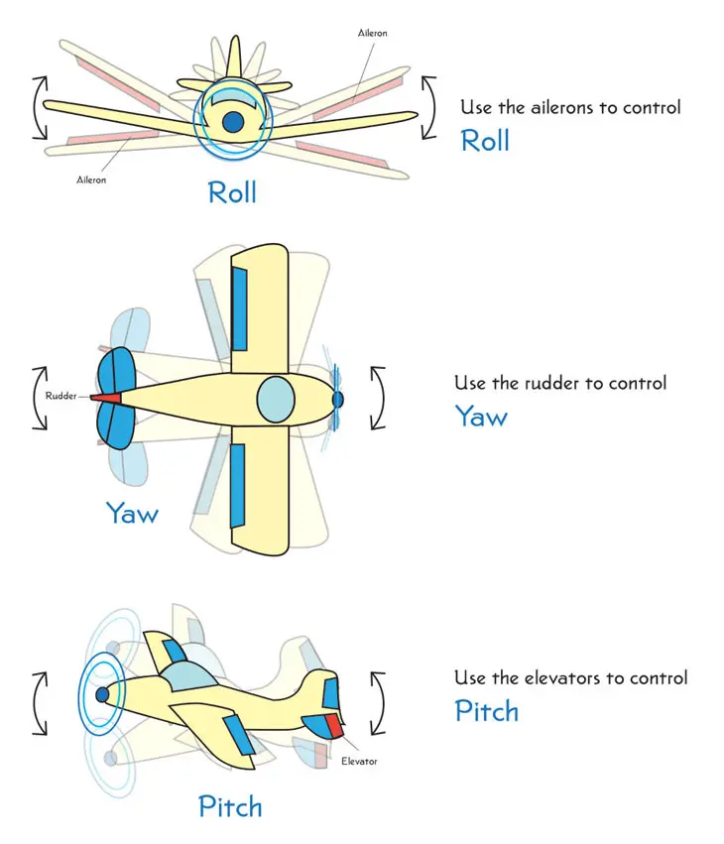
https://highsierrapilots.club/tahoe-minden-reno-discovery-flight/roll-pitch-yaw-diagram/

1.1 Yaw Rate
First you will learn how to measure yaw rate with the test stand. Put the test stand so that it is standing with the three legs on the ground with the attachment that will hold the drone parallel to the ground, as figure 4 shows.

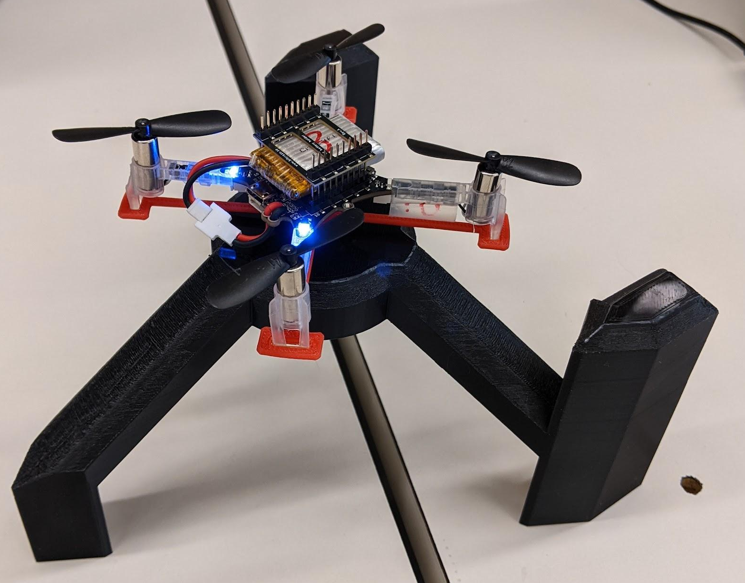
Figure 4. Yaw rate test stand setup

Now, connect to the Crazyflie and open the groundstation GUI. We will be graphing the test stand rotation rate and the yaw attitude rate setpoint. Details on how to use the test stand and how to setup plotting can be found above.

You can now send yaw rate setpoints and thrust setpoints via the ground station which will tell the Crazyflie to rotate at a certain speed, the test stand sensor will then measure the actual rate and display that on the GUI. However, with no PID constants set, the Crazyflie will not respond to setpoints. Your task is to change these constants through the GUI by setting parameters.

Relevant logging variables:
- MicroCART.Test_stand
  - This is the test stand data
- ctrlStdnt.yawRate
  - This is the yaw rate setpoint
- Optional
  - ctrlStdnt.r_yaw
    - This is the crazyflie’s on-board sensor for yaw rate measurements

Be sure to write down the PID values you find while tuning. They will be used in the second half of the lab and are required for submission. Also, the PID values are reset when the Crazyflie reboots, so be sure to write them down frequently!

Relevant parameters:
Group: s_pid_rate
- yaw_kp
- yaw_ki
- Yaw_kd

If the ground station becomes unresponsive or stops sending setpoints to the crazyflie, stop it by pressing ctrl + c in the terminal you launched it and restart it. The PID constants are stored in the crazyflie’s memory so they should be unchanged.

Your goal for this part of the lab is to demonstrate that you can send a yaw rate setpoint to the Crazyflie and then verify through the GUI ground station that the Crazyflie follows that setpoint closely.

1.2 Pitch Rate
Now change the mount attachment so that the Crazyflie will be held vertically and the left or right side of the drone is facing the table, as shown in figure 5.

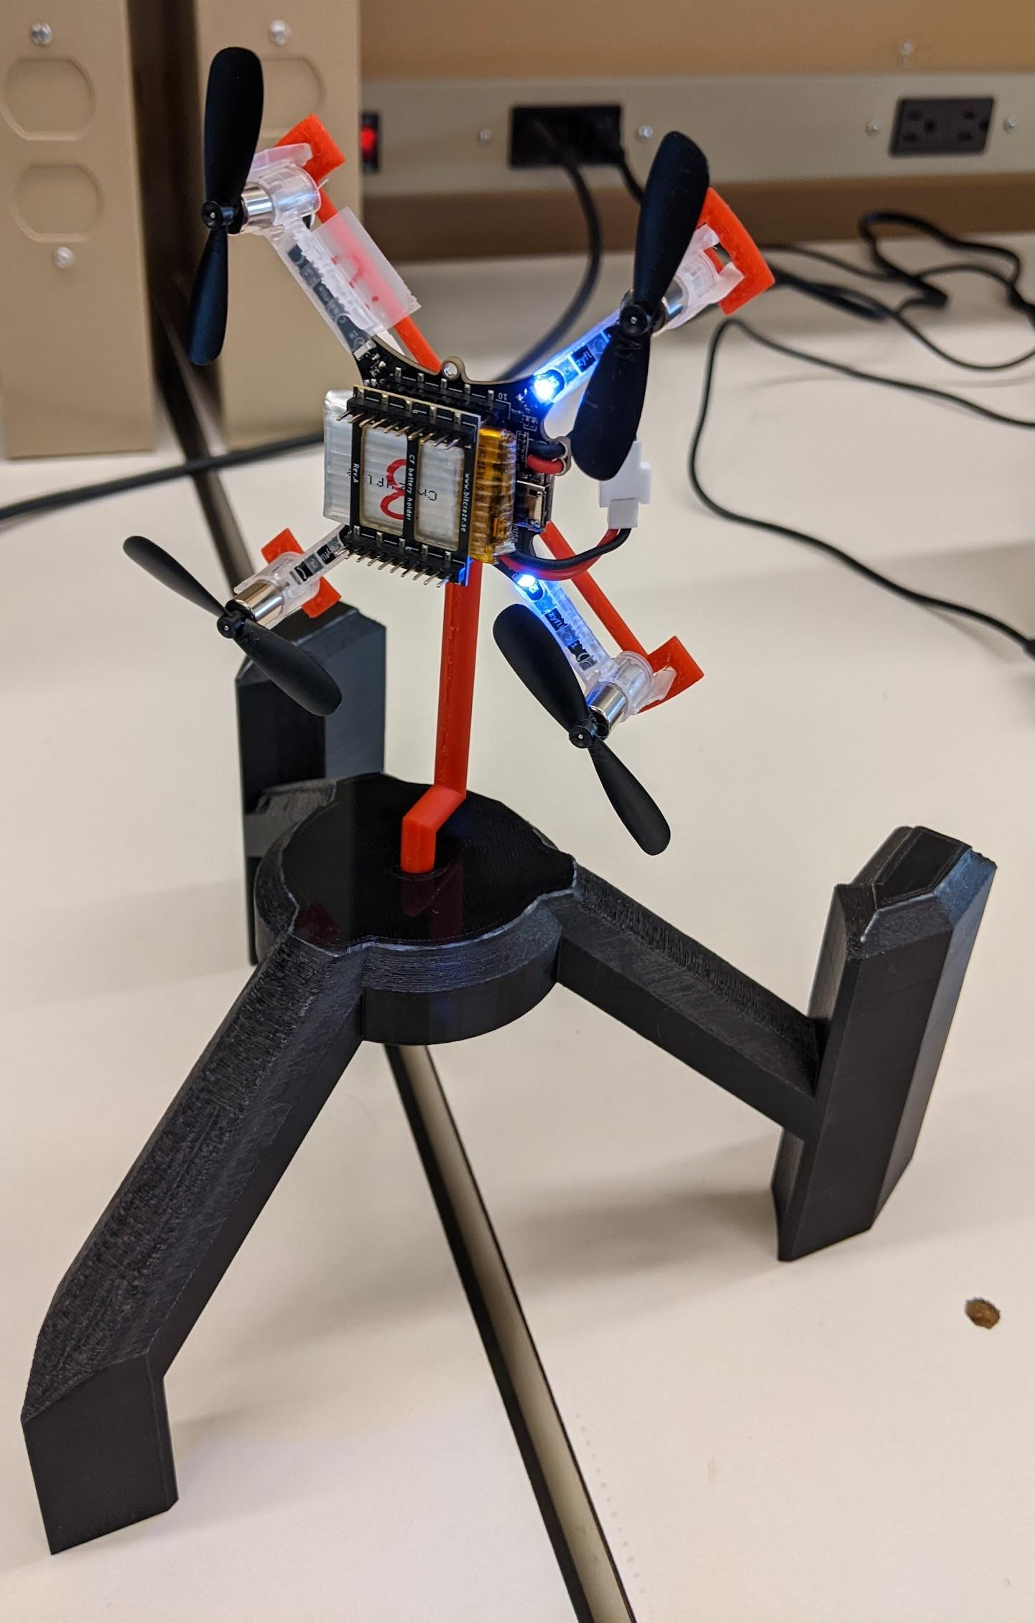
Figure 5. Pitch rate test stand setup

You will now be tuning pitch rate, this is how fast the Crazyflie tilts up or down. Repeat the process you did for tuning the yaw rate, but with the appropriate pitch rate parameters and logging values.

Remember to set the e_stop parameter under the sys group to 0

Relevant logging variables:
- MicroCART.Test_stand
  - This is test stand data
- ctrlStdnt.pitchRate
  - This is the pitch rate setpoint
- Optional
  - ctrlStdnt.r_pitch
    - This is the crazyflie’s on-board sensor for pitch rate measurements

Relevant parameters:
Group: s_pid_rate
- pitch_kp
- pitch_ki
- pitch_kd

1.3 Roll Rate
Change the orientation of the drone so that the front or back is facing the table.

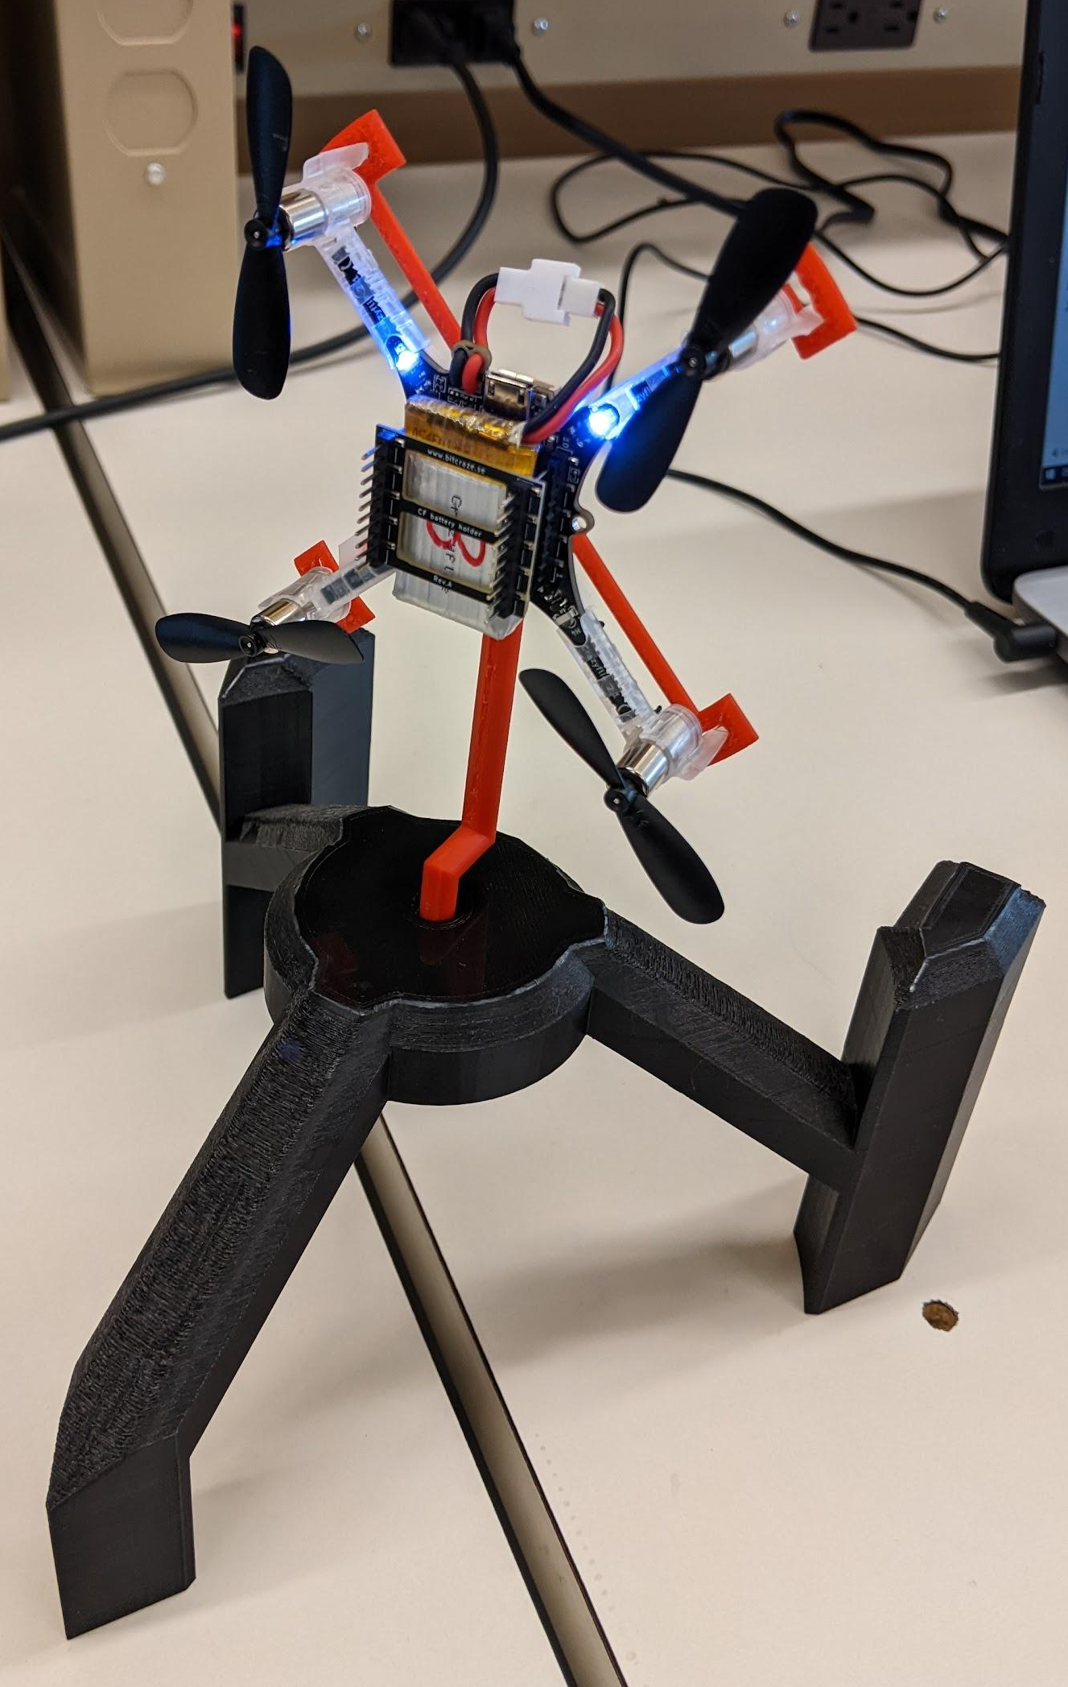

You will now be tuning roll rate, which is how fast the Crazyflie tilts to the side. Repeat the process you did for tuning the yaw rate and pitch rate, but with the appropriate roll rate parameters and logging values.

Remember to set the e_stop parameter under the sys group to 0

Relevant logging variables:
- MicroCART.Test_stand
  - This is test stand data
- ctrlStdnt.rollRate
  - This is the roll rate setpoint
- Optional
  - ctrlStdnt.r_roll
    - This is the crazyflie’s on-board sensor for roll rate measurements

Relevant parameters:
Group: s_pid_rate
- roll_kp
- roll_ki
- roll_kd

Attitude Position Control
We will now tune how the Crazyflie holds a specific attitude angle. Recall from figure 3 that the attitude PID controller provides the input to the attitude rate controller. Therefore, it is important that the rate controller works well before continuing.

1.4 Yaw
Change the test stand setup to how you measured yaw rate. You will now be tuning yaw, which is the angle that the Crazyflie is oriented. This is done similarly to yaw rate except you will be sending degrees rather than degrees per second setpoints. Note, there is a button built into the test stand for setting the 0 point of rotation, this can be used to approximately sync up the test stand angle measurement with the Crazyflie’s built-in measurement.
In the end you will demonstrate that you can make the Crazyflie rotate to and hold a specific yaw angle, confirming it through the GUI ground station.

Relevant logging variables:
- MicroCART.Test_stand
  - This is test stand data
- ctrlStdnt.yaw
  - This is the yaw setpoint
- Optional
  - stateEstimate.yaw
    - This is the crazyflie’s state estimator for yaw angle

Relevant parameters:
Group: s_pid_attitude
- yaw_kp
- yaw_ki
- yaw_kd

1.5 Pitch
For this part of the lab we will turn the test stand on its side and attach the other mount that will hold the Crazyflie parallel to the floor. Ensure the left or right side of the drone is facing the test stand, as shown in figure 6.

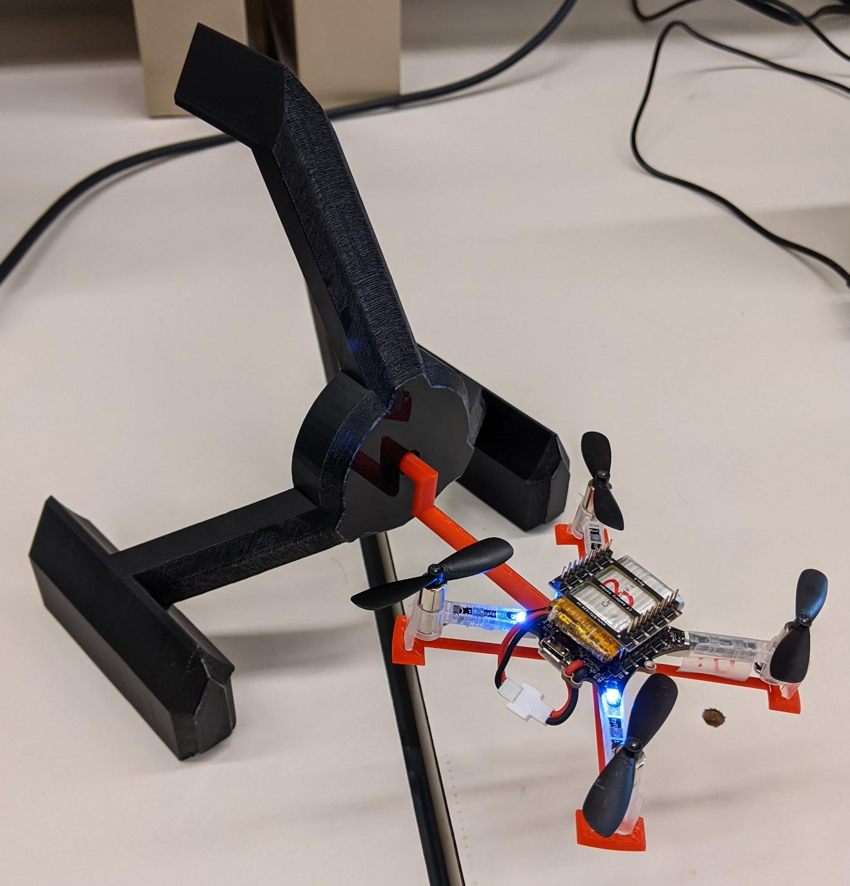
Figure 6. Pitch test stand setup

Repeat the process you did for tuning the yaw, but with the appropriate pitch parameters and logging values. You will demonstrate that you can make the Crazyflie rotate to and hold a specific pitch angle, confirming it through the GUI ground station.

Remember to set the e_stop parameter under the sys group to 0

Relevant logging variables:
- MicroCART.Test_stand
  - This is test stand data
- ctrlStdnt.pitch
  - This is the pitch setpoint
- Optional
  - stateEstimate.pitch
    - This is the crazyflie’s state estimator for pitch angle

Relevant parameters:
Group: s_pid_attitude
- pitch_kp
- pitch_ki
- pitch_kd

1.6 Roll
To measure the roll you will turn the drone 90 degrees such that the back or front of the drone is facing the test stand, as figure 7 shows.

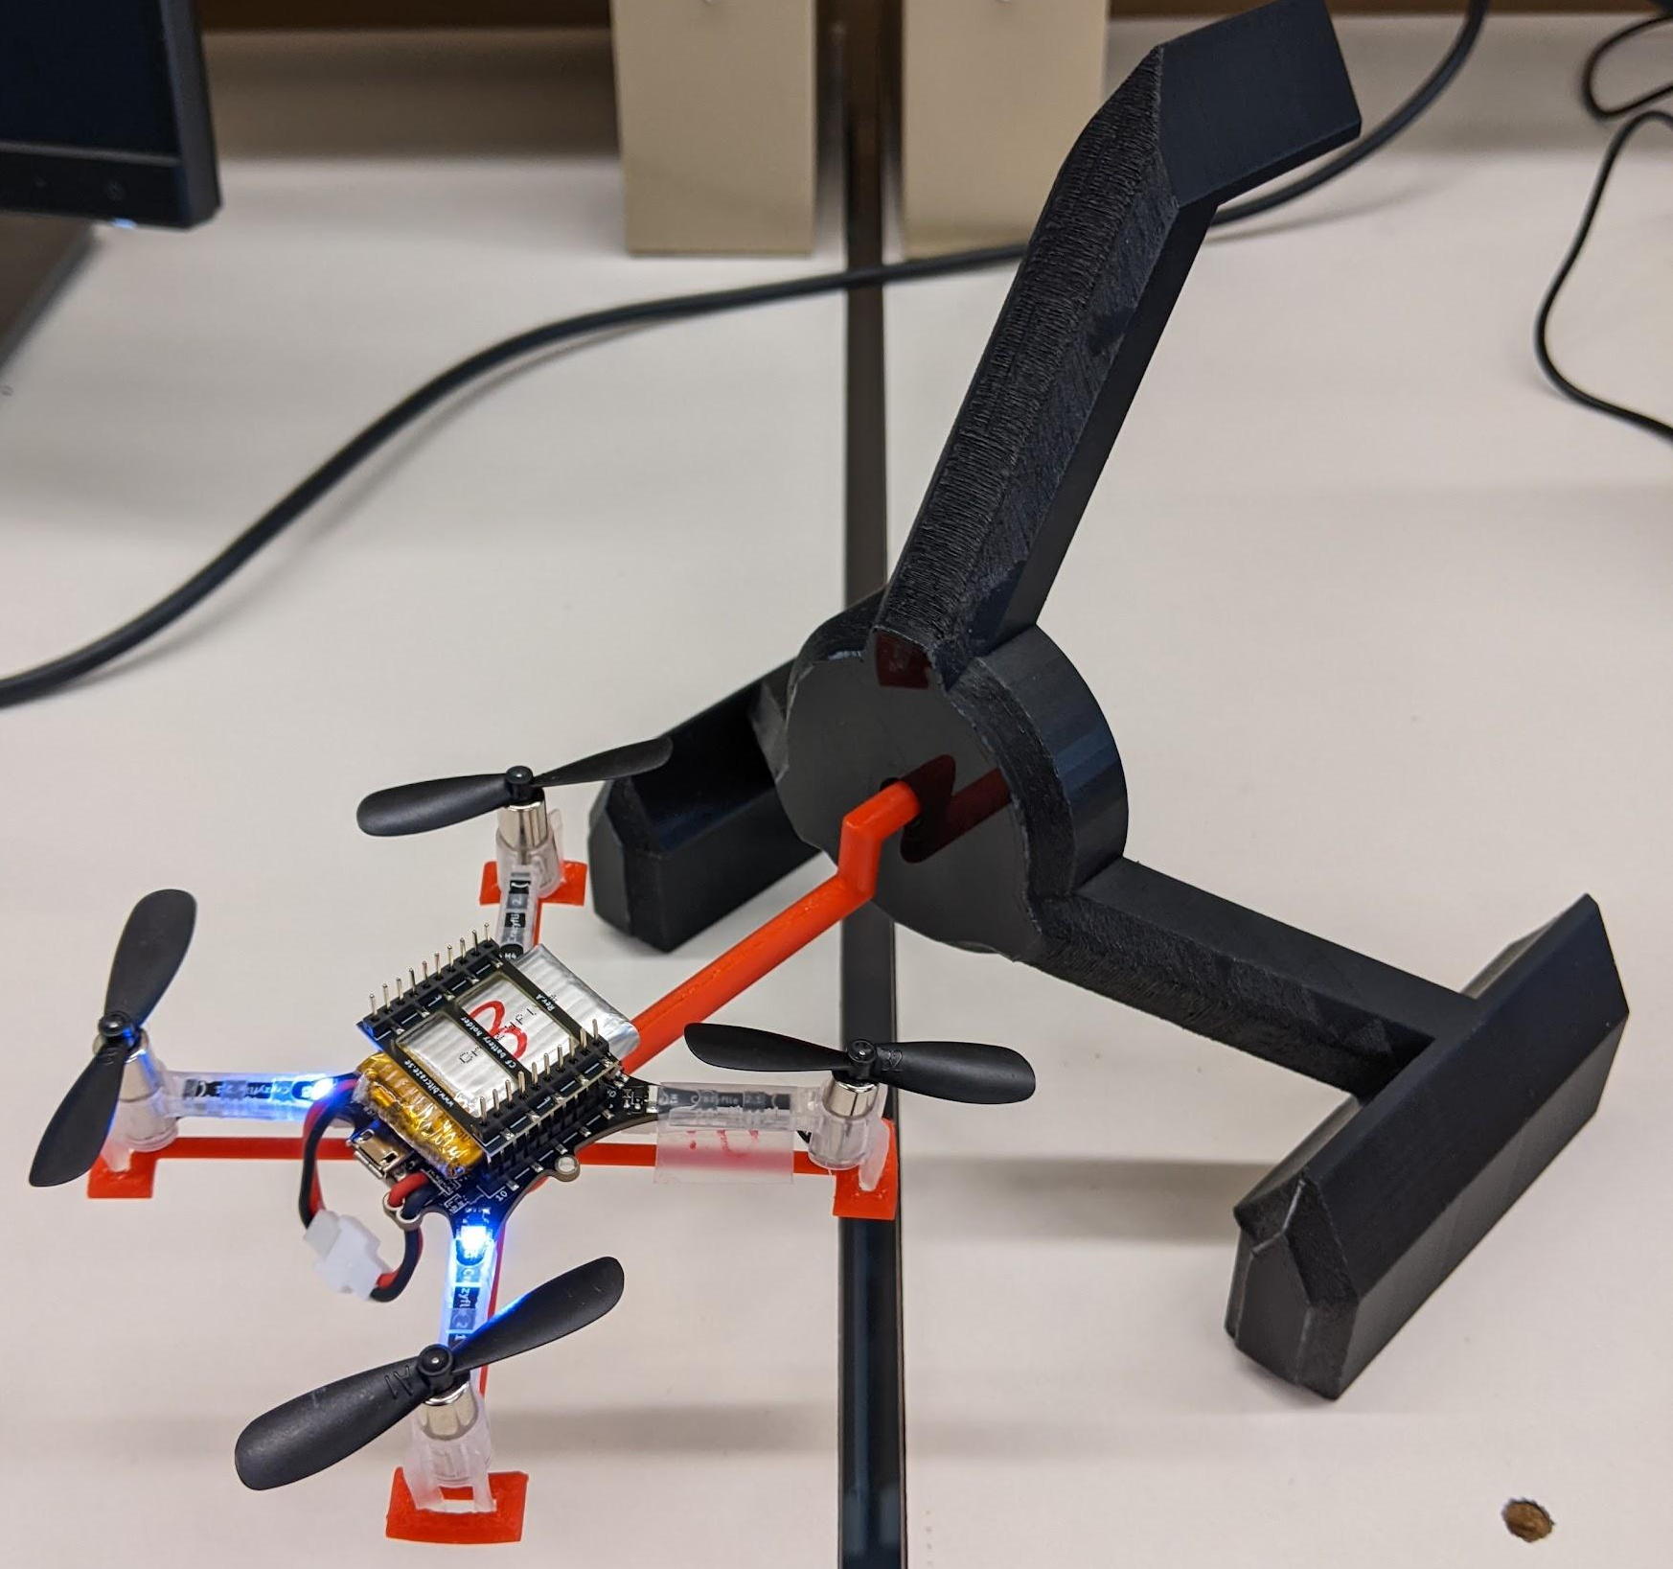
Figure 7. Roll test stand setup

Repeat the process you did for tuning the yaw and pitch, but with the appropriate roll parameters and logging values. You will demonstrate that you can make the Crazyflie rotate to and hold a specific roll angle, confirming it through the GUI ground station.

Remember to set the e_stop parameter under the sys group to 0

Relevant logging variables:
- MicroCART.Test_stand
  - This is test stand data
- ctrlStdnt.roll
  - This is the roll setpoint
- Optional
  - stateEstimate.roll
    - This is the crazyflie’s state estimator for roll angle

Relevant parameters:
Group: s_pid_attitude
- roll_kp
- roll_ki
- roll_kd

1.7 The Maiden Voyage
This final section of part 1 isn’t required but it may be a good idea (and fun) to check how your PID values work in real flight!

At this point you should be able to fully control all axes of the drone through a gamepad. Before you take off for real, it's always a good idea to check that your inputs do what you think they do while on the test stand.

See Gamepad Control for details on setting up and using a gamepad with the ground station GUI. Gamepad control uses a mixed setpoint setup where pitch and roll are given as absolute angles, and yaw is given as a rate.

Once everything looks ok on the test stand, carefully try to take off and get a feel for how she handles. Be aware of others in the lab! And try not to crash it too hard.

Part 2: Writing the Control Algorithm
For this part of the lab you will be writing your own control algorithms. Be sure to set up code exporting from the VM so you don’t lose your work.

All locations where you will need to write new code have been commented with 488 TODO. You can use VS code’s built-in search function to find all occurrences to make sure you haven’t missed anything.

Control Layout
The high level student controller, defined in controller_student.c, manages setting up setpoints and forwarding them to the attitude controller, whose output gets fed into the attitude rate controller. Both the attitude and attitude rate controller are defined in student_attitude_controller.c. The attitude and attitude rate controller utilize the base pid algorithms defined in student_pid.c. The output from the attitude rate controller gets passed back to the high level student controller where it then gets forwarded to other modules outside the scope of this lab.

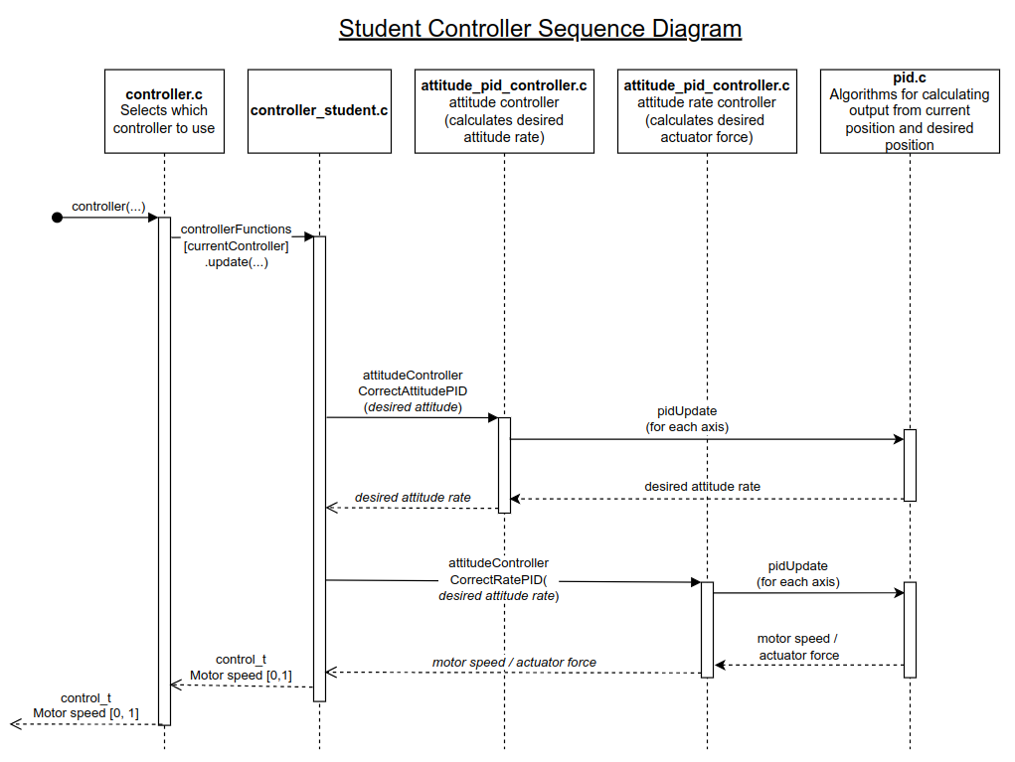

Understanding the Code
As a part of writing your own algorithms, it is important to understand the data structures used in the firmware. Additionally, it can be useful to specify what logging information to send to the ground station. Below are details on both subjects which will help in the development of your algorithms. Additionally there are some further details on compiling the Crazyflie firmware below.

Logging Instructions
- At the bottom of the controller_student.c and student_attitude_controller.c you will see a list of log commands. It should look like this in structure but with many more LOG_ADD commands and a couple of groups.
LOG_GROUP_START(pid_attitude)
/**
* @brief Proportional output roll
*/
LOG_ADD(LOG_FLOAT, roll_outP, <insert address here>)
LOG_GROUP_STOP(pid_attitude)

- This is how information is communicated to the ground station such as current yaw, pitch, roll and other information
- In the <insert address here> spot you will put a pointer to the address of the global variable you want to log (ex: you have named your output pitch variable outPitch, you would put &outPitch in the field and it would look like the following)

LOG_ADD(LOG_FLOAT, roll_outP, &outPitch)

- Now you know how to send information to the GUI ground station :)
- The parameter macros below the logging are how the GUI sets constants in the firmware, like you did with the PID constants in part 1.

Data Structures
There are four main structs that you will have to be familiar with that the state controller uses to communicate with other modules, all of them are defined in the /src/modules/interface/stabilizer_types.h file.
A small but important struct is the attitude struct, this contains roll, pitch, and yaw values as floats as well as a timestamp. Depending on the control context (viewable in the setpoint.mode struct) the values in this struct can represent degrees, or degrees per second for each axis.

typedef struct attitude_s {
uint32_t timestamp; // Timestamp when the data was computed

float roll;
float pitch;
float yaw;
} attitude_t;

Figure 8. Attitude struct

The first main struct is the state struct: it contains the Crazyflie's current attitude as well as other parameters that will not be of any use to you. Note that the current attitude rate is not available in the state struct. For this value you will need to read directly from the gyroscope described in the sensorData struct.

typedef struct state_s {
attitude_t attitude; // deg (legacy CF2 body
// coordinate system,
// where pitch is inverted)
quaternion_t attitudeQuaternion;
point_t position; // m
velocity_t velocity; // m/s
acc_t acc; // Gs (but acc.z without
// considering gravity)
} state_t;

Figure 9. State struct

The next major struct that you will interact with is the setpoint struct. This struct contains the setpoint information provided by the commander module which received its information from the ground station setpoints or a human input device. Like the other structs, it contains many fields of information you do not have to worry about. You need only be concerned with the fields for attitude, attitude rate, and thrust. The others like velocity and acceleration are not important because you will only be implementing an attitude controller, not a position or velocity controller.

Additionally, the mode struct controls how the data in the setpoint struct is interpreted. This information is set automatically based on the control method set by the ground station. For this lab, we are concerned with only two or three control modes, attitude control, attitude rate control, and mixed attitude control.

Attitude control
If:
- setpoint.mode.x y and z are set to modeDisable
- AND
- setpoint.mode. roll pitch and yaw are set to modeAbs
Then, the controller will use the values given by setpoint.attitude.
Attitude rate control
If:
- setpoint.mode.x y and z are set to modeDisable
- AND
- setpoint.mode. roll pitch and yaw are set to modeVelocity
The controller will use the values given by setpoint.attitudeRate. This mode ignores most of the control algorithm and only uses the attitude rate controller to stabilize and control the quad. This mode is useful if you want to hold a steady rotation speed of the quad body, this is what some other quads call “acro mode”.
Mixed Attitude control
If
- setpoint.mode.x y and z are set to modeDisable
- AND
- setpoint.mode. roll and pitch are set to modeAbs and setpoint.mode.yaw is set to modeVelocity
This allows the roll and pitch to be specified as a rate and the yaw to be an angle. This is the method used when a gamepad controller is used.

typedef struct setpoint_s {
uint32_t timestamp;

attitude_t attitude; // deg
attitude_t attitudeRate; // deg/s
quaternion_t attitudeQuaternion;
float thrust; //0 - 60,000
point_t position; // m
velocity_t velocity; // m/s
acc_t acceleration; // m/s^2
bool velocity_body; // true if velocity
//is given in body frame;
// false if velocity is
// given in world frame

struct {
stab_mode_t x;
stab_mode_t y;
stab_mode_t z;
stab_mode_t roll;
stab_mode_t pitch;
stab_mode_t yaw;
stab_mode_t quat;
} mode;
} setpoint_t;

Figure 10. Setpoint struct

The next struct is the control struct. This is the output of your control algorithm and represents the force to apply to the drone’s body. It is sent to the power distribution module which converts it into motor commands. Note that these are 16 bit int values, so a conversion must take place from a float.

typedef struct control_s {
int16_t roll;
int16_t pitch;
int16_t yaw;
float thrust;
} control_t;

Figure 11. Control struct

The last struct that you will interface with is the sensorData struct. This contains raw data from several sensors, including the gyroscope. You will need to access information contained in this struct for some of your rate PID calculations.

typedef struct sensorData_s {
Axis3f acc; // Gs
Axis3f gyro; // deg/s
Axis3f mag; // gauss
baro_t baro;
#ifdef LOG_SEC_IMU
Axis3f accSec; // Gs
Axis3f gyroSec; // deg/s
#endif
uint64_t interruptTimestamp;
} sensorData_t;

Figure 12. Sensor data struct

Compiling The Crazyflie Firmware
The crazyflie firmware can be compiled from the firmware root folder, /Lab_Part_2/crazyflie_software/crazyflie-firmware-2021.06/ by running make CONTROLLER=”Student”. After successful compilation, the binary files will be placed in the root of the firmware folder and can then be flashed to the crazyflie by following the instructions above.

make unit can also be used to run unit tests on the firmware, the unit tests are defined in /Lab_Part_2/crazyflie_software/crazyflie-firmware-2021.06/test/. You are free to add additional unit tests, however it is not required.

Writing the Code
Now that you understand the structure of the firmware, it's time to start writing your own algorithms. You may want to review Flashing the Crazyflie, when you’re ready to compile run make CONTROLLER="Student" from the root of the Crazyflie firmware.

Below is the suggested order of additions to make to the firmware.

2.1 General PID
Note, for this section you should use the PID constants you found in part 1 for known good values. You can set the default values in the student_pid.h file. However the constants you discovered earlier may have some assumptions built in so it may be necessary to re-tune the controller if a significantly different algorithm is used.

The first thing that you will write is a general PID function and struct. The PID struct that we provide you will be empty and you will decide on what should be included in it, that is defined in student_pid.h. You are encouraged to make as many helper functions that you would like in your student_pid.c file to help with roll, pitch and yaw calculations.

The first thing I would recommend writing is the PidObject struct in student_pid.h. This struct is used to hold the data that is used for all other PID calculations so it is required to write many of the other functions.

Next, write the basic getters and setters for the PidObject in student_pid.c.

Now we can actually write the PID algorithm in the studentPidUpdate function.

At this point, you should have filled out everything in student_pid.c and student_pid.h, make sure all of the “488 TODO” comments have been fulfilled in these files.

2.2 Attitude Rate Controller
The attitude rate controller’s main functions are in student_attitude_controller.c, this is where you should begin working.

2.3 Attitude Controller
The attitude controller’s main functions are also in student_attitude_controller.c.

At this point, you should have filled out everything in student_attitude_controller.c, make sure all of the “488 TODO” comments have been fulfilled in these files.

2.4 Student Controller, Bringing it all together
Now we need to bring everything together in the controller_student.c file.

At this point, you should have filled out everything in all files, make sure all of the “488 TODO” comments have been fulfilled.

Final Check
Before you go flying your Crazyflie for real, it's a good idea to verify everything works as intended on the test stand. Attach the drone to the test stand and briefly check that all axes respond how you expect. For this step you can use manual setpoints or a gamepad connected to the ground station, see here for details on using a gamepad with the ground station.

If all looks good, take her for a spin and see how she handles! Be careful of others in the lab and try not to crash it too hard!

What to submit
- Kp, Ki, and Kd constants for yaw rate, pitch rate, roll rate, yaw, pitch, and roll
- All documents that were edited in the firmware to complete part 2, see final export for details

If you’re hungry for further challenges, take a look at the extra credit section of this lab.

Extra Credit
- Give feedback on this lab
  - This is a new lab developed by the MicroCART team as a senior design project. We would appreciate some feedback on what you enjoyed about the lab and what can be improved.
  - Google Form Link
- Test Stand Data Visualization
  - As in MP-1, extra credit may be awarded to teams that make a creative visualization for the test stand position or rate data.
- Manual flight obstacle course
  - If teams can demonstrate their stable control algorithm by manually flying through an obstacle course extra points can be awarded. Film your obstacle runs and submit.
- Autonomous flight
  - The Crazyflie has many autonomous capabilities that we have not even touched in this lab. Extra credit will be awarded if you can write a short script to takeoff, fly forward, and land without using a controller.
  - You could write a short script that uses the ground station CLI to send commands over and over or you could use the crazyflie python library to send high level commands to the Crazyflie.
    - An additional circuit board, the flow deck, is required to use the crazyflie python library. If you wish to pursue this, talk to a TA and they can acquire a flow deck from the MicroCART team (microcart-f2021@iastate.edu).
    - Details on writing python scripts for the crazyflie can be found here

Document Version Changelog
- Version 1.1
  - Changed optional logging variables in lab part one from gyro.x, y, z to ctrlStdnt.r_roll, r_pitch, r_yaw
  - Changed git instructions for vm to use “Lab_Part_* folder” instead of “Microcart folder”
  - Updated student controller sequence diagram to have desired attitude rate being passed to the attitude rate controller
  - Removed “Test Stand Control Board Rate mode” extra credit & replaced it with test stand visualization extra credit

