MicroCART
Design Document

Team Number: 43
Client: Dr. Phillip Jones
Advisers: Dr. Phillip Jones
Team Members/Roles
Brandon Cortez - Team Lead, Test Station Sub-team
Reid Schneyer - Test Station Lead, Test Station Sub-team
Colton Glick - Git Manager, Firmware Sub-team
Ellissa Peterson - Tech Lead
Ryan Hunt - Firmware Sub-team Lead
Carter Irlmeier - Web Manager
Zachary Eisele - Firmware/Groundstation Sub-team
Team Email: sdmay22-43@iastate.edu
Team Website: https://sdmay22-43.sd.ece.iastate.edu
Revised: 12/5/2021

Executive Summary

Development Standards & Practices Used
- CI/CD pipeline in git
- 3D printing guidelines
  - IEEE P3030
  - https://ieeexplore.ieee.org/stamp/stamp.jsp?arnumber=7308141
- Bluetooth/Radio communication standards
  - https://standards.ieee.org/standard/802_15_1-2002.html

Summary of Requirements
- Test stand must record and transmit movement data to a host computer
- GUI must be multi-platform and display all relevant data
- Drone firmware must be modular so that control logic can be removed and substituted
- Augment a mini-quadcopter printed circuit board (PCB). Which will contain Integrated Circuits (ICs) such as a Microcontroller, RF, IMU, and Wi-fi chip
- Develop Software to stabilize, and communicate with the mini-quadcopter.
- Develop testing rigs to allow the team and users (CPRE 488 students) to remotely interact with the mini-quadcopter. For example, for tuning control algorithms to stabilize the mini-quadcopter

Applicable Courses from Iowa State University Curriculum
- CPRE 288
- COMS 309
- CPRE 458
- CPRE 488

New Skills/Knowledge acquired that was not taught in courses
- 3D Modeling Software
- Software Architecture of the Crazyflie Drone
- Operation of camera rig tracking system
- PID Controllers
- Socket Communication Protocols

Table of Contents
Team 6
Team Members 6
Required Skill Sets for Your Project 6
Skill Sets covered by the Team 6
Project Management Style Adopted by the team 6
Initial Project Management Roles 6
Introduction 6
Problem Statement 6
Requirements & Constraints 7
Engineering Standards 7
Intended Users and Uses 7
Project Plan 8
Project Management/Tracking Procedures 8
Task Decomposition 8
Project Proposed Milestones, Metrics, and Evaluation Criteria 9
Project Timeline/Schedule 10
Risks And Risk Management/Mitigation 11
Personnel Effort Requirements 12
Other Resource Requirements 12
Design 13
Design Context 13
Broader Context 13
User Needs 14
Prior Work/Solutions 14
Technical Complexity 14
Design Exploration 15
Design Decisions 15
Ideation 15
Decision-Making and Trade-Off 16
Proposed Design 16
Design Visual and Description 16
Functionality 18
Areas of Concern and Development 18
Technology Considerations 18
Design Analysis 19
Design Plan 19
Testing 20
Unit Testing 20
Interface Testing 20
Integration Testing 20
System Testing 21
Regression Testing 21
Acceptance Testing 21
Security Testing (if applicable) 21
Results 21
Implementation 22
Professionalism 22
Areas of Responsibility 22
Project Specific Professional Responsibility Areas 25
Most Applicable Professional Responsibility Area 26
Closing Material 26
Discussion 26
Conclusion 27
References 27
Appendices 27
Team Contract 27

List of figures/tables/symbols/definitions
- Figure 1: Project Plan Gantt Chart
- Figure 2: Crazyflie test stand 3D model
- Figure 3: Image of Crazyflie 2.0 mini quadcopter

- Table 1: Personnel Effort Requirements Table
- Table 2: Design Context Table
- Table 3: Area of Responsibility Table
- Table 4: Professional Responsibility Table

Team

Team Members
Brandon Cortez - Team Lead, Test Station Sub-team
Reid Schneyer - Test Station Lead, Test Station Sub-team
Colton Glick - Git Manager, Firmware Sub-team
Ellissa Peterson - Tech Lead
Ryan Hunt - Firmware Sub-team Lead
Carter Irlmeier - Web Manager
Zachary Eisele - Firmware/Groundstation Sub-team

Required Skill Sets for Your Project
- CAD 3D Design
- GitLab code/issue management
- Networking Protocols
- Software Architecture
- GUI Frameworks
- FPGA-based Hardware Design Tools

Skill Sets covered by the Team
- CAD 3D Design - Brandon, Reid
- GitLab code/issue management - Colton, Ellissa
- Networking Protocols - Colton, Zach
- Software Architecture - Ryan, Zach
- GUI Frameworks - Ellissa, Brandon
- FPGA-based Hardware Design Tools - Carter, Reid

Project Management Style Adopted by the team
AGILE Iterative Project Management System

Initial Project Management Roles
Brandon Cortez - Product Owner
Reid Schneyer - Developer
Colton Glick - CoScrum Master
Ellissa Peterson - CoScrum Master
Ryan Hunt - Developer
Carter Irlmeier - Developer
Zachary Eisele - Developer

Introduction

Problem Statement
What problem is your project trying to solve? Use non-technical jargon as much as possible
CPRE 488 students need a functional drone system where they can write their own control logic for in-class labs to learn more about advanced embedded systems. We are developing a platform to facilitate experimentation for these students.

Requirements & Constraints
List all requirements for your project. This includes functional requirements (specification), resource requirements, qualitative aesthetics requirements, economic/market requirements, environmental requirements, UI requirements, and any others relevant to your project. When a requirement is also a quantitative constraint, either separate it into a list of constraints or annotate at the end of the requirement as “(constraint)”. Other requirements can be a single list or can be broken out into multiple lists based on the category
- Test stand must record and transmit movement data to a host computer
- GUI must be multi-platform and display all relevant data
- Drone firmware must be modular so that control logic can be removed and substituted
- Augment a mini-quadcopter printed circuit board (PCB). Which will contain Integrated Circuits (ICs) such as a Microcontorllor, RF, IMU, and Wi-fi chip
- Develop Software to stabilize, and communicate with the mini-quadcopter.
- Develop testing rigs to allow the team and users (CPRE 488 students) to remotely interact with the mini-quadcopter. For example, for tuning control algorithms to stabilize the mini-quadcopter
- The quadcopter shall be affordable and easily maintainable to allow the department to support at least 20 units

Engineering Standards
What Engineering standards are likely to apply to your project? Some standards might be built into your requirements (Use 802.11 ac wifi standard) and many others might fall out of design. For each standard listed, also provide a brief justification
- Bluetooth Low Energy
- Must be compatible with existing Crazyflie standards and systems
  - Low-level C on the quadcopter, and Python for client application
- Potentially utilize a wifi standard within the 802.11 specifications for wifi communication

Intended Users and Uses
Who benefits from the results of your project? Who cares that it exists? How will they use it? Enumerating as many “use cases” as possible also helps you make sure that your requirements are complete (each use case may give rise to its own set of requirements).
- Students taking CPRE 488 in the Spring 2022 semester will benefit from our project as the lab uses quadcopters as a teaching tool.
- Iowa State University is also a potential beneficiary, a demonstration of the drones will attract potential students and corporate representatives

Project Plan

Project Management/Tracking Procedures
Which of agile, waterfall or waterfall+agile project management style are you adopting. Justify it with respect to the project goals.
Our team plans to use a waterfall+agile management style. The nature of our project is such that we can immediately begin adding features to the CrazyFlie, allowing an agile approach to work well. We plan to track our progress in the project through a GitLab kanban board. Tasks/issues will be created on the board as we begin development, which will then be assigned to different members of the team. Additionally, milestones with due dates will be created to make sure we are keeping a good pace as the project progresses.

Task Decomposition
In order to solve the problem at hand, it helps to decompose it into multiple tasks and subtasks and to understand interdependence among tasks. This step might be useful even if you adopt the agile methodology. If you are agile, you can also provide a linear progression of completed requirements aligned with your sprints for the entire project.
Tasks to Complete:

- Investigate CrazyFlie firmware architecture
  - Learn how to modify and flash a new firmware to the CrazyFlie
  - What is the current architecture structure?
  - Can the control code be easily modified?
  - How easy is the control code to understand for new users?
- Modify CrazyFlie firmware to be as modular as possible
  - Abstract the control code to a standardized interface to allow other control algorithms to be easily implemented through an adapter architecture
  - Rewrite the existing control code to utilize the new interface
- Add wifi capabilities to the CrazyFlie
  - Research current communication protocols in the CrazyFlie firmware
  - Electrical connection between wifi chip and CrazyFlie
  - Test communication over wifi
  - Control drone over wifi with less than 20 ms of latency
- Test different control algorithms on the CrazyFlie
  - Write a basic PID control loop to maintain a stable hover, using the new interface
- Develop ground station software to communicate with and control CrazyFlie
  - Start with a command-line interface on Linux
  - Build a GUI/frontend once the backend is mostly working
- Develop test stand hardware
  - Determine what electronics will be used to record & communicate data
  - Integrate chosen electronics into test stand for data collection
  - Design and print test stand model to mount CrazyFlie
- Develop test stand software to measure and log rotation of the CrazyFlie while held in test stand
  - Should collect and record all desired data from the CrazyFlie in real-time
  - Should communicate with the ground station to allow for easy saving of log data
- Write lab instructions and documentation for interfacing and using the modified CrazyFlie
  - Basic quick start guide
  - Detailed proposed lab activities
- Stretch goal: Convert control algorithm from MatLab code to C code that works with our interface

Project Proposed Milestones, Metrics, and Evaluation Criteria
What are some key milestones in your proposed project? It may be helpful to develop these milestones for each task and subtask from 2.2. How do you measure progress on a given task? These metrics, preferably quantifiable, should be developed for each task. The milestones should be stated in terms of these metrics: Machine learning algorithm XYZ will classify with 80% accuracy; the pattern recognition logic on FPGA will recognize a pattern every 1 ms (at 1K patterns/sec throughput). ML accuracy target might go up to 90% from 80%.
In an agile development process, these milestones can be refined with successive iterations/sprints (perhaps a subset of your requirements applicable to those sprints).
Project Milestones;

- Working test stand prototype
  - 3D printed and assembled
  - Electronics selected and assembled
  - Firmware is written and reporting back
- Custom firmware running on CrazyFlie
  - First modified firmware running on CrazyFlie
  - Control software abstracted with adapter interface
  - Existing control code running through adapter
- Custom ground station CLI
  - Control commands can be sent to CrazyFlie and an acknowledgment is sent back
- Ground station GUI based on CLI
  - Basic GUI that sends pre-configured commands through the CLI
  - More advanced GUI that displays flight data and allows for gamepad controls

Project Timeline/Schedule
- A realistic, well-planned schedule is an essential component of every well-planned project
- Most scheduling errors occur as the result of either not properly identifying all of the necessary activities (tasks and/or subtasks) or not properly estimating the amount of effort required to correctly complete the activity
- A detailed schedule is needed as a part of the plan:
  - Start with a Gantt chart showing the tasks (that you developed in 2.2) and associated subtasks versus the proposed project calendar. The Gantt chart shall be referenced and summarized in the text.
  - Annotate the Gantt chart with when each project deliverable will be delivered
  - Project schedule/Gantt chart can be adapted to the Agile or Waterfall development model. For agile, a sprint schedule with specific technical milestones/requirements/targets will work.
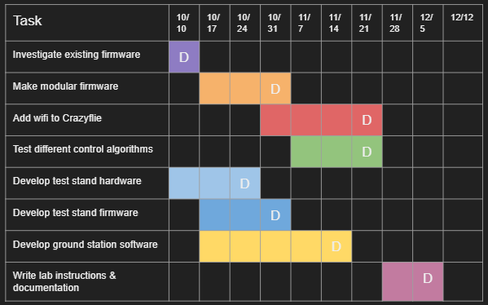
Figure 1. Project plan Gantt chart of milestones and deliverables.

Risks And Risk Management/Mitigation
Consider for each task what risks exist (certain performance targets may not be met; certain tools may not work as expected) and assign an educated guess of probability for that risk. For any risk factor with a probability exceeding 0.5, develop a risk mitigation plan. Can you eliminate that task and add another task or set of tasks that might cost more? Can you buy something off-the-shelf from the market to achieve that functionality? Can you try an alternative tool, technology, algorithm, or board?
Agile projects can associate risks and risk mitigation with each sprint.

Risks:
- Firmware is much harder to adapt to an adapter architecture, takes longer than expected, 60%
  - Mitigation plan: Begin researching and modifying the CrazyFlie firmware as soon as possible. May need to push back tasks that are dependent on this, the different control algorithms, and lab instructions.
- CLI cannot communicate with CrazyFlie, 30%
- Wifi chip is not compatible, 50%
  - Mitigation plan: Look for other wifi alternative chips that are proven compatible with the CrazyFlie. Else fall back to current radio communication protocols.
- Wifi communication latency is greater than 30 ms, 70%
  - Mitigation plan: review previous years’ code, as they have worked with wifi in the past and gotten the latency very low. speak with Jones about this.
- GUI takes too long to create, 40%

Personnel Effort Requirements
Include a detailed estimate in the form of a table accompanied by a textual reference and explanation. This estimate shall be done on a task-by-task basis and should be the projected effort in the total number of person-hours required to perform the task.
Task | Time Estimate (Hours) | Explanation
Investigate existing firmware | 21 ± 5 | Depends on firmware complexity
Create modular firmware | 35 ± 8 | Depends on firmware complexity
Add wifi to Crazyflie | 36 ± 5 | Will need custom firmware to work
Test control algorithms | 15 | Create modular control algorithm for CrazyFlie
Develop ground station software | 30 | Create CLI & GUI for communicating with Crazyflie
Develop test stand hardware | 16 | Design & build test stand
Develop test stand software | 20 | Write firmware for test stand electronics
Write lab instructions | 12 | Create assignment for CPRE 488 lab
Stretch: MatLab to C code conversion | TBD | Convert MatLab control algorithms to C code for students to use
Table 1. Table of Personnel Effort Requirements by milestone

Other Resource Requirements
Identify the other resources aside from financial (such as parts and materials) required to complete the project.
- Access to several CrazyFlie drones to test and develop on
- Development computers running Linux to build and test the system on
- ETG access for 3D printing components of the test stand

Design

Design Context

Broader Context
Describe the broader context in which your design problem is situated. What communities are you designing for? What communities are affected by your design? What societal needs does your project address?
Our project has a fairly narrow context, all things considered. We’re designing for Iowa State University students interested in learning more about complex embedded systems, specifically those taking CPRE 488 in the spring 2022 semester. The project addresses the societal need of needing skilled embedded programmers as more and more devices are created and manufactured.

List relevant considerations related to your project in each of the following areas:
Area | Description | Example
Public health, safety, and welfare | How does your project affect the general well-being of various stakeholder groups? These groups may be direct users or they may be indirectly affected (e.g., the solution is implemented in their communities) | The drone could cause minor injury if it collides with an individual
Global, cultural, and social | How well does your project reflect the values, practices, and aims of the cultural groups it affects? Groups may include but are not limited to specific communities, nations, professions, workplaces, and ethnic cultures. | The drone will be used to teach engineering students more about advanced embedded systems
Environmental | What environmental impact might your project have? This can include indirect effects, such as deforestation or unsustainable practices related to materials manufacture or procurement. | The batteries the drones use are not great for the environment and are prone to catch fire
Economic | What economic impact might your project have? This can include the financial viability of your product within your team or company, the cost to consumers, or broader economic effects on communities, markets, nations, and other groups. | An impressive drone demo could attract potential corporate or private donors, and potential future students
Table 2. Table of Broader Design Context

User Needs
List each of your user groups. For each user group, list a needs statement in the form of
User group needs (a way t0) do something (i.e., a task to accomplish, a practice to implement, a way to be) because of some insight or detail about the user group.
CPRE 488 needs a functional drone system where they can write their own control logic for in-class labs to learn more about advanced embedded systems.

Prior Work/Solutions
Include relevant background/literature review for the project
- If similar products exist in the market, describe what has already been done
- If you are following previous work, cite that and discuss the advantages/shortcomings
- Note that while you are not expected to “compete” with other existing products/research groups, you should be able to differentiate your project from what is available. Thus, provide a list of the pros and cons of your target solution compared to all other related products/systems.
Detail any similar products or research done on this topic previously. Please cite your sources and include them in your references. All figures must be captioned and referenced in your text.
We are following previous work that has been done for years, most recently by the 2020 MicroCART team. This is advantageous in that we have code and repositories (https://git.ece.iastate.edu/danc/MicroCART/-/tree/2020-team-final-state) to look at, but we definitely are operating a different project. We are dealing with a much smaller version and different kind of drone than what has been used previously, which will definitely differentiate our work from others.

Technical Complexity
Provide evidence that your project is of sufficient technical complexity. Use the following metric or argue for one of your own. Justify your statements (e.g., list the components/subsystems and describe the applicable scientific, mathematical, or engineering principles)
- The design consists of multiple components/subsystems that each utilize distinct scientific, mathematical, or engineering principles –AND–
- The problem scope contains multiple challenging requirements that match or exceed current solutions or industry standards.
The design consists of multiple components/subsystems that each utilize distinct scientific, mathematical, or engineering principles. These components/subsystems are:
- Groundstation
  - includes computer software skills
- CrazyFlie drone
  - includes computer hardware skills
- Firmware flashed to the CrazyFlie
  - includes computer engineering skills
  - Will utilize several popular software engineering principles such as Separation of Concerns, Modularity, Abstraction, and Incremental Development
- Test Stand
  - involves 3D modeling,
  - electrical engineering
  - embedded systems

Design Exploration

Design Decisions
List key design decisions (at least three) that you have made or will need to make in relation to your proposed solution. These can include but are not limited to, materials, subsystems, physical components, sensors/chips/devices, physical layout, features, etc.
- wifi chip decision
- what exactly to do for the demonstration
- how the GUI will look
- what system(s) the control will be used on
- What sensors will be embedded in the test stand

Ideation
For one design decision, describe how you ideated or identified potential options (e.g., lotus blossom technique). List at least five options that you considered.
We identified potential options for sensors needed through client and group requirement discussions and brainstorming:
- Sensors
  - Rotation
  - Vibration
  - Voltage
  - Gyroscope
  - IR

Decision-Making and Trade-Off
Demonstrate the process you used to identify the pros and cons or trade-offs between each of your ideated options. You may wish you include a weighted decision matrix or other relevant tools. Describe the option you chose and why you chose it.
Our process for creating these pros and cons was through discussion with the client and group members to make sure we covered all areas of concern.
- Affordability (keeping in mind project budget),
- Availability (what is in stock and what the lab already has),
- What fits our design
- What works with our firmware

Proposed Design
Discuss what you have done so far – what have you tried/implemented/tested?
- We have tested our existing interface and fleet of drones.
- We evaluated the existing test stand designs and began to modify them to house the sensors we decided to include.
- Using an absolute decoder we have monitored drone movement on the test stand.

Design Visual and Description
Include a visual depiction of your current design. Different visual types may be relevant to different types of projects. You may include: a block diagram of individual components or subsystems and their interconnections, a circuit diagram, a sketch of physical components and their operation, etc.
Describe your current design, referencing the visual. This design description should be in sufficient detail that another team of engineers can look through it and implement it.

Test Stand Model:
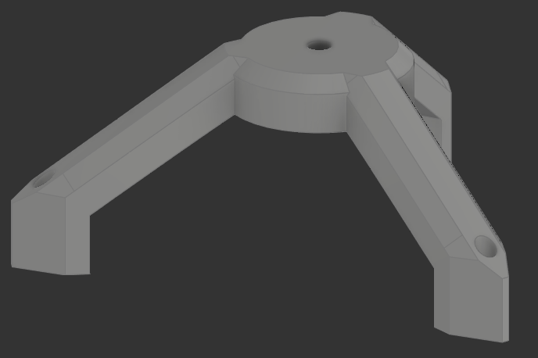
Figure 2. Crazyflie test stand 3D model

Our current drone is the CrazyFlie 2.0. The Crazyflie 2.0 is a versatile open-source flying development platform that weighs 27g and fits in the palm of your hand. Crazyflie 2.0 is equipped with low-latency/long-range radio as well as Bluetooth LE.
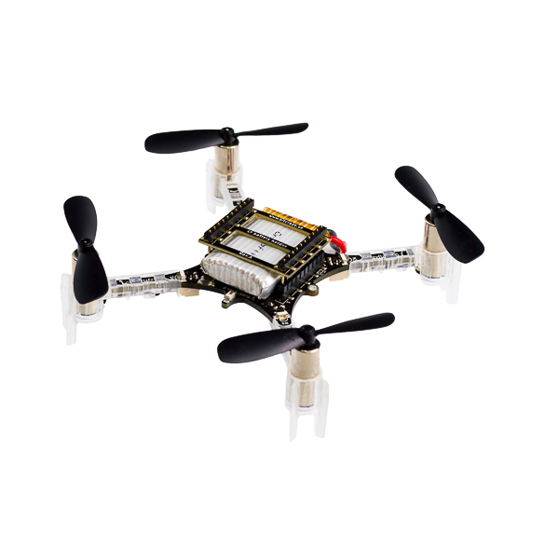
Figure 3. Crazyflie 2.0 mini quadcopter

Functionality
Describe how your design is intended to operate in its user and/or real-world context. This description can be supplemented by a visual, such as a timeline, storyboard, or sketch.
Our design will let students create their own control logic for the drone and let students gather data from the test stand as well as to show off when prospective students visit.

How well does the current design satisfy functional and non-functional requirements?
Our design is a work in progress. Our plans fit the functional and non-functional requirements but so far we have not gotten far enough to implement any requirements.

Areas of Concern and Development
Based on your current design, what are your primary concerns for delivering a product/system that addresses requirements and meets user and client needs?
Our primary concern is that the existing firmware will not be compatible with current hardware.

What are your immediate plans for developing the solution to address those concerns? What questions do you have for clients, TAs, and faculty advisers?
We are addressing these concerns by researching other firmware for the Crazyflie so if worst comes to worst, we can just create our own firmware based on the Crazyflie open-source firmware. A question for our client that we have is where is the firmware interface (which was talked about in a previous meeting) located in the git?

Technology Considerations
Highlight the strengths, weaknesses, and trade‐offs made in technology available.
Discuss possible solutions and design alternatives
In working on our senior design project, we had to determine which type of protocol we would use to communicate between the ground station and the Crazyflie drone. The ground station that Bitcraze provides uses a radio antenna, but Professor Jones wanted us to look into using either Bluetooth or WiFi to communicate in our ground station software. While the Crazyflie does have an existing Bluetooth IC, we would have to use a separate board for WiFi communication, such as the ESP8266. Professor Jones’ concern was that Bluetooth might have more latency than going with the Wifi option, since we could use socket communication over Wifi.

Design Analysis
Did your proposed design from 4.3 work? Why or why not?
– What are your observations, thoughts, and ideas to modify or iterate over the design?
Our proposed design from 4.3 worked to the minimum requirements of our client. The system delivers the required functionality requested by our client, however it utilizes multiple machines to do so. Going forward in our next iteration our goal is to consolidate the processes onto one ground station desktop to run all the required features in one cohesive process.

Design Plan
Describe a design plan with respect to use-cases within the context of requirements, modules in your design (dependency/concurrency of modules through a module diagram, interfaces, architectural overview), module constraints tied to requirements.
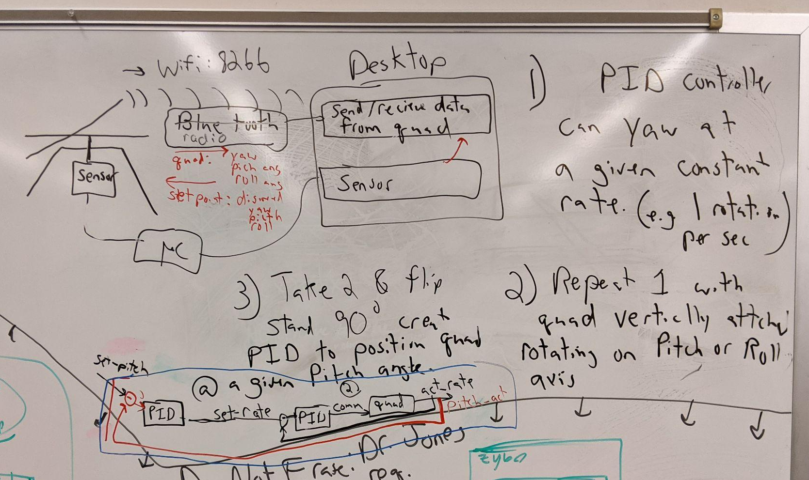
Figure 4. Module Interface Diagram
Our design plan is divided into three teams, the ground station, the test stand, and the firmware. I will first go over the individual requirements for each team then the requirements of all of the teams together. The plan for the ground station is to start with the previous years Micro Cart ground station as there was an adapter made for the crazyflie last year, then improve upon it with any information that would be beneficial for students to use in the 488 lab. For the test stand the design plan is to first create a test stand similar to one created from a previous team then see what could be improved upon with it, make a new design with the previous flaws in mind. This will be continued till the design fits all of the needs. The next step would be adding sensors onto the stand so that students can get measurements from the crazyflie quadcopter and create hardware that will display the sensor data. The design plan for firmware is to become familiar with the current firmware and figure out how the PID controls work, then implement our own PID controller so that it could then be stripped down into a template for 488 students. The plan for making these parts work together will be first setting up communication between the crazyflie and ground station with data being sent and read both ways. The second part of communication would be the groundstation getting data from the test stand sensors and displaying that data. To begin, this data link will be through the crazyflie radio. In future iterations we plan to switch to bluetooth or wifi communication to standardize the system more.

Testing
Testing is an extremely important component of most projects, whether it involves a circuit, a process, a power system, or software.

The testing plan should connect the requirements and the design to the adopting test strategy and instruments. In this overarching introduction, given an overview of the testing strategy. Emphasize any unique challenges to testing for your system/design.

Unit Testing
What units are being tested? How? Tools?
Quadcopter software:
- Any units inside of the quadcopter coding can be tested, this will include a variety of functions. An example would be a flying algorithm. This can be tested by making a testbench for the function and running it.
Testing station:
- The unit testing for this part of the project would pertain to making sure we are getting correct data from the sensors. This can be done by measuring the values vs expected values of what the sensor is measuring.
GUI Base station:
- The unit testing for the GUI will be for it to display the proper information, this may include some calculations which would also be a part of the unit test. These would be tested by writing a testbench and making sure the values match the expected

Interface Testing
What are the interfaces in your design? Discuss how the composition of two or more units (interfaces) are being tested. Tools?
N/A (Does not apply)

Integration Testing
What are the critical integration paths in your design? Justification for criticality may come from your requirements. How will they be tested? Tools?
The integration in our design will be between the GUI ground control and the test stand and between the quadcopter and the GUI ground control. We can test the interfacing with the GUI ground control and test stand by sending data from the test stand to the GUI and making sure it gets what was actually sent. We can test the communication between the quadcopter and the GUI by sending a command with the GUI and checking if the quadcopter responds accordingly.

System Testing
Describe system-level testing strategy. What set of unit tests, interface tests, and integration tests suffice for system-level testing? This should be closely tied to the requirements. Tools?
The System we are testing in our design is from the base station to the GUI then to the quadcopter. This can be tested by first sending a command from the GUI to the quadcopter where then the Test station sensors will record data from the movements of the quadcopter then send that data to the GUI.

Regression Testing
How are you ensuring that any new additions do not break the old functionality? What implemented critical features do you need to ensure do not break? Is it driven by requirements? Tools?
When creating new additions we are using version control in conjunction with testing to ensure that all bugs and issues are resolved before the master branch is updated.

Acceptance Testing
How will you demonstrate that the design requirements, both functional and non-functional are being met? How would you involve your client in the acceptance testing?
We can demonstrate our design meets the requirements to our client by giving an in-person demonstration of our complete project. We would involve our client, as well as the TAs, in this by guiding them through how our solution works first by individually showing them each part then how they all work together.

Security Testing (if applicable)
N/A

Results
What are the results of your testing? How do they ensure compliance with the requirements? Include figures and tables to explain your testing process better. A summary narrative concluding that your design is as intended is useful.
The results of our testing will show that each part of the design works as stated in the requirements. They shall show compliance with the requirements if the client is satisfied with our design. If our design meets all of the requirements as intended then it will be useful.

Implementation
Describe any (preliminary) implementation plan for the next semester for your proposed design in 4.3. If your project has inseparable activities between design and implementation, you can list them either in the Design section or this section.
For the upcoming semester, we are planning to first finish the setup and documentation for use in the CprE 488 lab that this project will be a part of. Following the completion of the lab material, we hope to begin exploring the capabilities that the IR camera system can provide us for autonomous flight demonstrations.

Professionalism
This discussion is with respect to the paper titled “Contextualizing Professionalism in Capstone Projects Using the IDEALS Professional Responsibility Assessment”, International Journal of Engineering Education Vol. 28, No. 2, pp. 416–424, 2012

Areas of Responsibility
Pick one of IEEE, ACM, or SE code of ethics. Add a column to Table 1 from the paper corresponding to the society-specific code of ethics selected above. State how it addresses each of the areas of seven professional responsibilities in the table. Briefly describe each entry added to the table in your own words. How does the IEEE, ACM, or SE code of ethics differ from the NSPE version for each area?

Area of Responsibility | Definition | NSPE Canon | IEEE Code of Ethics
Work Competence | Perform work of high quality, integrity, timeliness,  and professional competence. | Perform services only in areas of their competence;  Avoid deceptive acts. | To maintain and improve our technical competence and to undertake  technological tasks for others only if qualified by training or experience, or after  full disclosure of pertinent limitations;  to improve the understanding of technology; its appropriate application, and  potential consequences.
Financial Responsibility | Deliver products and services of realizable value and  at reasonable costs. | Act for each employer or client as faithful agents or  trustees. | To reject bribery in all its forms.
Communication Honesty | Report the work truthfully, without deception, and  understandable to stakeholders. | Issue public statements only in an objective and  truthful manner; Avoid deceptive acts. | To avoid real or perceived conflicts of interest whenever possible, and to  disclose them to affected parties when they do exist;  to be honest and realistic in stating claims or estimates based on available  data.
Health, Safety, Well-Being | Minimize risks to safety, health, and well-being of  stakeholders. | Hold paramount the safety, health, and the welfare of the  public. | To accept responsibility in making decisions consistent with the safety, health,  and welfare of the public, and to disclose promptly factors that might endanger  the public or the environment.
Property Ownership | Respect property, ideas, and information of clients  and others. | Act for each employer or client as faithful agents or  trustees. | To seek, accept, and offer honest criticism of technical work, to acknowledge  and correct errors, and to credit properly the contributions of others.
Sustainability | Protect the environment and natural resources locally  and globally. |  | To accept responsibility in making decisions consistent with the safety, health,  and welfare of the public, and to disclose promptly factors that might endanger  the public or the environment.
Social Responsibility | Produce products and services that benefit society  and communities. | Conduct themselves honorably, responsibly,  ethically, and lawfully so as to enhance the honor,  reputation, and usefulness of the profession. | To treat fairly all persons, and to not engage in acts of discrimination based on  race, religion, gender, disability, age, national origin, sexual orientation, gender  identity, or gender expression; to avoid injuring others, their property, reputation, or employment by false or  malicious action; to assist colleagues and co-workers in their professional development and to  support them in following this code of ethics.
Table 3. Table of project areas of responsibility

- Work Competence - The NSPE code refers both to areas of competence and deceptive acts while the IEEE code of ethics focuses more primarily on only working within areas of competence and qualifications.
- Financial Responsibility - The NSPE code of ethics discusses acting as good agents on a client’s behalf while the IEEE code primarily focuses on refusing deceptive acts such as bribery.
- Communication Honesty - The NSPE code focuses on making public statements responsibly while the IEEE code focuses primarily on avoiding conflicts of interest and communicating transparently both externally and internally.
- Health, Safety, Well-Being - Both the NSPE and the IEEE codes of ethics focus on maintaining the safety and well-being of the public and the environment.
- Property Ownership - The NSPE discusses acting as good agents for the client while the IEEE focuses on respecting ideas and criticism and being respectful and honest in the acknowledgment of errors.
- Sustainability - While the NSPE does not discuss sustainability, the IEEE code discusses making decisions to protect the safety and health of both the public and the environment/
- Social Responsibility - The NSPE code discusses working honestly and ethically while the IEEE code goes beyond that to focus on avoiding discrimination and other non-ethical acts.

Project Specific Professional Responsibility Areas
For each of the professional responsibility areas in Table 1, discuss whether it applies in your project’s professional context. Why yes or why not? How well is your team performing (High, Medium, Low, N/A) in each of the seven areas of professional responsibility, again in the context of your project? Justify.

Professional Responsibility | Project Application
Work Competence | Why/why not? -  Our project will be used by future students thus it needs to be of high enough quality that it can be comprehended in the future to aid in education.  Performance(Medium):  We are continuously working to better our code but our documentation could be improved to help with future comprehension.
Financial Responsibility | Why/why not? -  We are not buying or selling any products of significant value.  Performance(N/A):
Communication Honesty | Why/why not? -  We’ve had to communicate our progress to our contact on a weekly basis.  Performance(High):  We write up weekly status reports, as well as communicate frequently in discord and through email with our contact.
Health, Safety, Well-Being | Why/why not? -  We do have potentially harmful equipment being used in our workroom.  Performance(High):  Safety protocols are in place and used during development and testing.
Property Ownership | Why/why not? -  We use university-provided resources and technology in our development laboratory.  Performance(High):  We have been respectful of the lab & equipment, especially the sensitive drone electrical components.
Sustainability | Why/why not? -  Sustainability is not a large part of our project as we use primarily small amounts of standard-grade plastic components.  Performance(N/A):  The scope of our project uses limited supplies and creates minimal waste.
Social Responsibility | Why/why not? -  Our project does not have a high social responsibility because it is going to be used primarily only by future students.  Performance(High):  Although we do not have a high social responsibility, we are developing our project with the safety and education of the user in mind.
Table 4. Table of project-specific professional responsibilities

Most Applicable Professional Responsibility Area
Identify one area of professional responsibility that is both important to your project, and for which your team has demonstrated a moderate or high level of proficiency in the context of your project. Briefly describe what this responsibility means to your project, the ways in which your team has demonstrated the responsibility in the project, and specific impacts to the project that you have observed.

Professional Responsibility:
Communication Honesty

Description, Demonstration, and Impacts:
For our project Communication Honest consists of reporting our work to our client truthfully, transparently, and without deception. We demonstrate this responsibility by providing detailed reports to our client on a weekly basis that communicate our team’s progress, what we achieved, what we are spending our time and resources on, and what our plans for the future are. Communicating clearly and honestly in this manner has allowed us to receive critical feedback from our client on our performance in order to improve our team’s performance as the project progresses.

Closing Material

Discussion
Discuss the main results of your project – for a product discuss if the requirements are met, for experiments-oriented project – what are the results of the experiment, if you were validating a hypothesis – did it work?
Our solution successfully fulfilled our client’s product requirements. Our system allows CPRE 488 students to control the Crazyflie drone from a ground station while sensors in the test stand monitor the movement and behavior of the drone.

Conclusion
Summarize the work you have done so far. Briefly reiterate your goals. Then, reiterate the best plan of action (or solution) to achieving your goals. What constrained you from achieving these goals (if something did)? What could be done differently in a future design/implementation iteration to achieve these goals?
- Our goal for our final product is to have a polished collection of processes running on a single ground station device to allow CPRE 488 students to manipulate the Crazyflie drone and view data from its sensors.
- So far we have successfully met our client’s requirements by creating a system that allows CPRE 488 students to control a drone mounted on a test stand that monitors and returns data on the drone’s movements.
- While our current design satisfies the minimum requirements of our client, in our next iteration we hope to have a more polished, user-friendly interface for the CPRE 488 students to be able to use.

References
List technical references and related work/market survey references. Do professional citation style (ex. IEEE).

US Digital, “MA3 Miniature Absolute Magnetic Shaft Encoder”, MA3 datasheet,
Jun. 2021 [Accessed 06-Dec-2021].
“Bitcraze,” GitHub. [Online]. Available: https://github.com/bitcraze. [Accessed: 06-Dec-2021].
“Distributed Autonomous Networked Control Lab / microcart,” GitLab. [Online]. Available: https://git.ece.iastate.edu/danc/MicroCART. [Accessed: 06-Dec-2021].
“Start here,” Bitcraze. [Online]. Available: https://www.bitcraze.io/documentation/start/. [Accessed: 06-Dec-2021].
“CRTP - Communication with the Crazyflie,” Bitcraze. [Online]. Available: https://www.bitcraze.io/documentation/repository/crazyflie-firmware/2021.06/functional-areas/crtp/. [Accessed: 06-Dec-2021].

Appendices

Team Contract
Team Name: sdmay22-proj43
Team Members: Brandon Cortez, Carter Irlmeier, Colton Glick, Ellissa Peterson,
Reid Schneyer, Ryan Hunt, Zachary Eisele

Team Procedures:
- Day, time, and location (face-to-face or virtual) for regular team meetings:
  - Weekly Wednesday 11 am - 12 pm Coover 3050 with Dr. Jones
  - Weekly Wednesday 1 pm - 2 pm Discord, general meeting with TA
  - Weekly Tuesday 7 pm - 10 pm Coover 3050, Workday
  - Weekly Thursday 7 pm - 10 pm Coover 3050, Workday
- Preferred method of communication updates, reminders, issues, and scheduling (e.g., e-mail, phone, app, face-to-face):
  - Email or Discord server
- Decision-making policy (e.g., consensus, majority vote):
  - Majority vote
- Procedures for record-keeping (i.e., who will keep meeting minutes, how will minutes be shared/archived):
  - Google drive folder for meeting minutes. Record meeting minutes for Monday and Wednesday meetings.

Participation Expectations:
- Expected individual attendance, punctuality, and participation at all team meetings:
  - All members shall have regular attendance to both general meetings.
  - All members should go to as many workdays as possible, attendance for at least 1 of the 3 hours is expected.
  - Meeting absences should be communicated to the team ahead of time.
  - Members can call in virtually if they cannot attend in person. However, in-person is preferred.
- Expected level of responsibility for fulfilling team assignments, timelines, and deadlines:
  - All members shall contribute equally to team assignments. Deadlines for assignments shall be clearly communicated and met.
  - Each member is responsible for their own portion of the assignment.
- Expected level of communication with other team members:
  - Team members should communicate impediments and roadblocks to the team regularly during meetings or on the Discord server.
  - During team meetings, team members should communicate openly and honestly regarding their thoughts and opinions on project aspects.
- Expected level of commitment to team decisions and tasks:
  - If a team decides on a certain task by majority vote, the entire team should carry out what is voted on. However, if there are concerns about the decision, they should be communicated in a professional manner, so that the entire team is on the same page.

Leadership
- Leadership roles for each team member (e.g., team organization, client interaction, individual component design, testing, etc.):
  - 2 technical leads will be determined later once a better understanding of technical requirements is gained
  - Ellissa (Brandon will assist) will be the project manager
- Strategies for supporting and guiding the work of all team members:
  - Discussing roadblocks during general meetings and workdays
- Strategies for recognizing the contributions of all team members:
  - Each member discusses accomplishments/narratives for the previous week during general meetings.

Collaboration & Inclusion
- Describe the skills, expertise, and unique perspectives each team member brings to the team.
  - Colton: Previous programming experience in Java, C, C++, among other languages. Worked with some real-time aerospace control systems before. Have worked with real-world agile teams before.
  - Zach: Programming experience in Java, C/C++, and some experience using Javascript (primarily using Node.js and Three.js). Have done data visualization and worked with agile teams during an internship. Only embedded systems experience is with CPR E 288 (wanting to learn more). Some 3D modeling experience with Blender.
  - Brandon: Programming experience in Java, Javascript, C/C++, Python. Experience managing projects at internship and experience with designing in AutoCAD tools. Limited experience with embedded systems from 288.
  - Reid: Programming experience in C, Java, Javascript. Has designed & assembled custom PCBs. Embedded experience from CPRE 288 and hardware design experience from CPRE 381, 480, 581. Has worked on Agile teams before. Some 3D modeling experience.
  - Carter: Previous school work experience programming in C/C++, Java, Javascript, and Python; Real-world experience working in an agile environment and programming with Java and utilizing SQL; no experience with embedded systems or control systems, unfortunately.
  - Ellissa: Programming experience in Java, C, C++, C#, Ruby, JavaScript, SQL, and Python. I also have experience with Node.js, Vue, ReactJS, and Angular. I have a small amount of experience with embedded systems and 3D modeling but not enough to be confident with them. I've had three internships over the past few summers where I was able to experience working in various agile environments.
  - Ryan: programming experience in Java and C. Embedded system experience with CPRE 288. Hardware experience from CPRE 381 and some real-world work with FPGAs. A small bit of experience with scripting.
- Strategies for encouraging and supporting contributions and ideas from all team members:
  - Brainstorming and problem-solving sessions where anyone can present ideas/solutions.
- Procedures for identifying and resolving collaboration or inclusion issues (e.g., how will a team member inform the team that the team environment is obstructing their opportunity or ability to contribute?)
  - Team members can bring any concerns to the group during the weekly standups, or the retrospective meetings
  - Or if uncomfortable, directly to the TA.

Goal-Setting, Planning, & Execution
- Team goals for this semester:
  - Work and communicate well as a team
  - Establish a productive working environment to plan and prototype effectively
  - Have a manual flying prototype by the end of the semester
- Strategies for planning and assigning individual and teamwork:
  - Project work will be planned and estimated on an agile kanban board to effectively estimate and distribute work
- Strategies for keeping on task:
  - Weekly standups
  - Monthly retrospective meetings

Consequences for Not Adhering to Team Contract
- How will you handle infractions of any of the obligations of this team contract?
  - Team will talk with the member in question over Discord to resolve contract violations.
- What will your team do if the infractions continue?
  - If a member repeatedly violates the contract, the TA and/or professor will be contacted to help resolve the issue. Disciplinary action may be taken if deemed necessary.

a) I participated in formulating the standards, roles, and procedures as stated in this contract.
b) I understand that I am obligated to abide by these terms and conditions.
c) I understand that if I do not abide by these terms and conditions, I will suffer the consequences as stated in this contract.
1) Colton Glick_______________________________________ DATE 9/17/21____________
2) Zachary Eisele ____________________________________ DATE 9/17/21____________
3) Reid Schneyer_____________________________________ DATE 9/17/21____________
4) Ellissa Peterson____________________________________ DATE 9/17/21____________
5) Brandon Cortez____________________________________ DATE 9/17/21____________
6) Rayn Hunt________________________________________ DATE 9/18/21____________
7) Carter Irlmeier_____________________________________ DATE 9/19/21____________

